

2015 Air Quality
Updating and Screening Assessment
In fulfillment of Part IV of the Environment Act 1995 Local Air Quality Management

September 2015

Falkirk Council

Local Authority Officers | Jon Flitney  Reviewed by: Alf Hillis and Graeme Webster.
Department | Environmental Health
Address | Abbotsford House, David’s Loan, Falkirk, FK2 7YZ.
Telephone | 01324 504950
E-mail | envhealth@falkirk.gov.uk
Report Reference | Updating and Screening Assessment (Air Quality) 2015
Date | September 2015



Falkirk Council

Executive Summary
Falkirk Council has examined the air quality monitoring results in its area and concludes that no new Detailed Assessments are required of any pollutant.

In 2014 the Falkirk West Bridge St automatic monitoring site and the diffusion tube on the same street breached the annual NO₂ objective. There were no other diffusion tubes that breached the annual NO₂ objective. In addition, no automatic monitoring sites breached the annual or daily PM₁₀ objectives.

The six SO₂ automatic monitors met all three (15%minute, hourly and daily) objectives during 2014. However, the number of exceedances at the Grangemouth MC site could be considered to be close to the 15%minute objective with 30 exceedances. There were no exceedances of the hourly or daily limit value at the monitoring sites. The 2014 results continue the objective compliance recorded both in 2013 and since the commissioning of the Tail Gas Unit at the refinery.

The benzene and 1,3 butadiene diffusion tube monitoring conducted in 2014 met the objectives. The PM_{2.5} monitor at the Grangemouth AURN site recorded a concentration of 8 Gg/m³. This is within the Scottish Government’s interim target value of 12 Gg/m³ and the proposed 10 Gg/m³ objective.

There have been numerous changes to the automatic monitoring network in 2014 and early 2015. These changes are a new PM₁₀ and PM_{2.5} analyser at the Banknock 2 site, the re% location of the Falkirk Park St enclosure and SO₂ analyser to Grangemouth Zetland Park, a new site in Bainsford utilising the former Park St NO_{x} and PM₁₀ analysers and a new enclosure and NO_{x} analyser at Falkirk West Bridge St. Thus monitoring has commenced in the area of the only outstanding Detailed Assessment along Main St Bainsford.

A review of local and trunk roads resulted in three DMRB runs being conducted and no Detailed Assessments are required. No industrial processes or other sources required further consideration.

Since the 2014 Progress Report the Falkirk and Haggs action plan has been submitted and accepted. An update on the Falkirk, Haggs and Grangemouth AQMA Action Plans is provided.

Falkirk Council

Table of contents

- Introduction 8
  - Description of Local Authority Area 8
  - Purpose of Report 8
  - Air Quality Objectives 9
  - Summary of Previous Review and Assessments 11
- New Monitoring Data 17
  - Summary of Monitoring Undertaken 17
    - Automatic Monitoring Sites 17
    - Non%Automatic Monitoring Sites 19
  - Comparison of Monitoring Results with Air Quality Objectives 26
    - Nitrogen Dioxide 26
    - PM₁₀ 41
    - Sulphur Dioxide 46
    - Benzene 53
    - Other Pollutants Monitored 54
- Road Traffic Sources 58
  - Narrow Congested Streets with Residential Properties Close to the Kerb 59
  - Busy Streets Where People May Spend 1%hour or More in proximity to Traffic 59
  - Roads with a High Flow of Buses and / or HGVs 59
  - Junctions and busy roads in Scotland 60
  - New Roads Constructed or Proposed Since the Last Round of Review and Assessment.
. 61
  - Roads with Significantly Changed Traffic Flows 63
  - Bus and Coach Stations 63
- Other Transport Sources 65
  - Airports 65
  - Railways (Diesel and Steam Trains) 65
    - Stationary Trains 65
    - Moving trains 66
  - Ports (Shipping) 67
- Industrial Sources 68
  - Industrial Installations 68
    - New or Proposed Installations for which an Air Quality Assessment has been carried out
. 68
    - Existing installations where emissions have increased substantially or new relevant exposure has been introduced 68
    - New or Significantly Changed Installations with No Previous Air Quality Assessment 68
  - Major Fuel (Petrol) Storage Depots 69
  - Petrol Stations 69
Falkirk Council
  - Poultry Farms 69
- Commercial and Domestic Sources 71
  - Biomass Combustion – Individual Installations 71
  - Biomass Combustion – Combined Impacts 71
  - Domestic Solid%Fuel Burning 71
- Fugitive or Uncontrolled Sources 73
- AQMA, Action Plan and Other Strategy or Policy Updates 74
- Conclusions and Proposed Actions 88
  - Conclusions from New Monitoring Data 88
  - Conclusions from Assessment of Sources 88
  - Proposed Actions 88
- References 90
- Appendices 91

Falkirk Council

List of Tables
Table 2.1 Details of Automatic Monitoring Sites 18
Table 2.2 Details of Non%Automatic Monitoring Sites 21
Table 2.3 Results of Automatic Monitoring of Nitrogen Dioxide: Comparison with Annual Mean Objective (40 Gg/m³). 27
Table 2.4 Results of Automatic Monitoring for Nitrogen Dioxide: Comparison with 1%hour mean Objective (18 exceedances of 200 Gg/m³). 28
Table 2.5 Average NO₂ concentrations across all NO₂ diffusion tubes. 34
Table 2.6 Results of Nitrogen Dioxide Diffusion Tubes in 2014. 35
Table 2.7 Results of Automatic Monitoring of PM₁₀: Comparison with Annual Mean Objectives (18 and 40 Gg/m³) 42
Table 2.8 Results of Automatic Monitoring for PM₁₀: Comparison with 24%hour mean Objectives (7 and 35 exceedances of 50 Gg/m³) 43
Table 2.9 Results of Automatic Monitoring of SO₂: Comparison with Objectives. 48
Table 2.10 Results of pumped benzene diffusion tube. 53
Table 2.11 Results of passive benzene diffusion tubes. 53
Table 2.12 Results from 1,3 butadiene diffusion tubes. 54
Table 2.13 Results from PM_{2.5} monitoring. 55
Table 3.1 Results of the DMRB runs. 60
Table 8.1 Update on Grangemouth AQMA Action Plan measures 77
Table 8.2 Update on Falkirk and Haggs Action Plan Measures 82
Table A1 Short%term to long%term adjustments. 94
Table A2 Details of the QA/QC at the automatic monitoring stations in 2014. 96
Table A3 Pumped diffusion tube (Grangemouth AURN) results in full. 102
Table A4 a.) Benzene, b.) 1,3 butadiene and c.) nitrogen dioxide results in full. 103
Table A5 Background concentrations used in DMRB runs. 105
Table A6 Other input data to the DMRB runs. 105
Table A7 Verification for DMRB runs. 105

Falkirk Council

List | of Figures
Figure 1.1 Maps of AQMA Boundaries in the Falkirk Council area. |  | 14
 | a.) Grangemouth AQMA (15%minute SO₂), declared November 2005. | 14
 | b.) Falkirk Town Centre AQMA (annual NO₂), declared March 2010. | 15
 | c.) Haggs AQMA (annual NO₂), declared March 2010. | 15
 | d.) Banknock AQMA (PM₁₀), declared August 2011. | 16
Figure 2.1 Map of the new Non%Automatic Monitoring Site (NA112, Philip St, Bainsford). 20
Figure 2.2 Trends in Nitrogen Dioxide Concentrations (deseasonalised) at three Automatic Monitoring Sites, a.) Grangemouth AURN, b.) Falkirk West Bridge St and c.) Haggs. 29
Figure 2.3 Monthly average NO₂ concentrations at all diffusion tube sites in 2013 and 2014.33 Figure 2.4 NO₂ diffusion tube monitoring results in a.) Falkirk Town Centre and b.) Haggs
AQMAs. 39
Figure 2.5 Trends in PM₁₀ Concentrations at a.) Grangemouth AURN and b.) Falkirk West Bridge St. 44
Figure 2.6 a.) Number of exceedances at the three SO₂ monitoring sites in the Grangemouth AQMA between 2009 and 2014. 49
b.) Monthly concentrations at the Grangemouth Moray site between 2007 and 2014. 50
Figure 2.7 Polar Plots of SO₂ Concentrations in the Grangemouth AQMA in 2014. 51
Figure 2.8 Polar Plots of SO₂ Concentrations in the Grangemouth AQMA in 2012. 52
Figure 2.9 a.) Deseasonalised and b.) absolute PM_{2.5} concentrations at Grangemouth between December 2008 and December 2014. 55
Figure 3.1 All motor vehicles traffic on major roads in Falkirk Council area, 2000 to 2014 58
Figure 3.2 Photos of a.) the old and b.) new road layout along Glensburgh Road, Grangemouth. 62
Figure 3.3 A photograph of First Group’s hybrid bus during its launch. 63
Figure 3.4 The photograph accompanying First Group’s announcement of their new vehicle order. 64
Figure 6.1 A map of the merged smoke control areas in the Falkirk Council area. 72
Figure 8.1 Picture of traffic lights at the Main St, Bainsford and Bankside junction. 79
Figure A1 The boundary of the Falkirk Council area. 91
Figure A2 NO₂ bias adjustment factor at Grangemouth MC (A10) and the R&A bias sheet.92 Figure A3: Precision of ESG Didcot, 50% TEA/Acetone diffusion tubes in 2014. 93
Figure A4 Certificate of calibration of the Scottish Air Quality Network monitoring sites 98

Falkirk Council

Appendices
Appendix A Falkirk Council boundary and QA/QC of monitoring data. Appendix B DMRB Calculations

Abbreviations

AADT | Annual Average Daily Traffic (flow)
AQMA | Air Quality Management Area
ATD | Atomic Thermal Desorption
AURN | Automatic Urban and Rural Network
DA | Devolved Administration
DMRB | Design Manual for Roads and Bridges
FDMS | Filter Dynamics Measurement System
FIDAS | Fine Dust Analysis System
HDVs | Heavy Duty Vehicles
LAQM | Local Air Quality Management
LSO | Local Site Operator
MOVA | Microprocessor Optimised Vehicle Actuation
n/a | not applicable
n/m | not measured
NO₂ | Nitrogen dioxide
PM10 / 2.5 | Particulate matter (less than 10 / 2.5 Gm in diameter)
PR | Progress Report
QA/QC | Quality Assurance / Quality Control
PPC | Pollution, Prevention and Control (Regulations)
R&A | Review and Assessment (Helpdesk, run by Defra / DAs)
SAQN | Scottish Air Quality Network
SEPA | Scottish Environmental Protection Agency
SO₂ | Sulphur dioxide
TEOM | Tapered Element Oscillating Microbalance
U&SA | Updating and Screening Assessment
VCM | Volatile Correction Model

Introduction

Description of Local Authority Area
Falkirk Council is a unitary authority located in Central Scotland, see Figure A1. The Falkirk Council area encompasses 290 square kilometres with a population of approximately 151,000. The area extends from Banknock in the west to Blackness in the east and from South Alloa in the north to Limerigg in the south. It is bordered by the local authorities of North Lanarkshire, Stirling and West Lothian, with Clackmannanshire and Fife located on the north side of the Firth of Forth.

The area contains the port of Grangemouth and depends for its prosperity on a broad industrial base which includes sizeable industrial areas in Falkirk and Grangemouth. These industrial areas are diverse and vary from an oil refinery, associated chemical industry and dockland in Grangemouth through to bus manufacturing in Camelon (Falkirk). The main towns and population base in the area are Bo’ness, Denny, Falkirk, Grangemouth and Larbert with the south of the area around Slamannan being more rural in nature.

Three motorways pass through the area, the M80, M876 and M9, in addition to the main rail line connecting Glasgow and Edinburgh and the rail lines connecting Glasgow / Edinburgh with Stirling and the north. The area also contains the Falkirk Wheel, which connects the Union canal with the Forth and Clyde canal, and the recently opened Helix Park and Kelpies.

Purpose of Report
This report fulfils the requirements of the Local Air Quality Management process as set out in Part IV of the Environment Act 1995, the Air Quality Strategy for England, Scotland, Wales and Northern Ireland 2007 and the relevant Policy and Technical Guidance documents. The LAQM process places an obligation on all local authorities to regularly review and assess air quality in their areas, and to determine whether or not the air quality objectives are likely to be achieved. Where a breach of the objective monitored or modelled, the local authority must then declare an Air Quality Management Area (AQMA) and prepare an Air Quality Action Plan setting out the measures it intends to put in place in pursuit of the objectives. Local authorities are required to work towards achieving the objectives.

The aim of an Updating and Screening Assessment (U&SA) is to identify any matters that have changed which may lead to risk of an air quality objective being exceeded. A checklist approach and screening tools are used to identify significant new sources or changes and whether there is a need for a Detailed Assessment.

Please note the LAQM process is under review by the Scottish Government. This will result in changes to the format of future reports and it is likely that the pollutants within the remit of LAQM will change.

Air Quality Objectives
The air quality objectives applicable to LAQM in Scotland are set out in the Air Quality (Scotland) Regulations 2000 (Scottish SI 2000 No 97), the Air Quality (Scotland) (Amendment) Regulations 2002 (Scottish SI 2002 No 297). Table 1.1 shows the objectives in units of microgrammes per cubic metre μg/m³ (and milligrammes per cubic metre, mg/m³ for carbon monoxide) with the number of exceedances in each year that are permitted (where applicable).

It was announced by the Scottish Government in December 2013 that Local Authorities will be required to review PM_{2.5} (particles smaller than 2.5 Gm in diameter). The legislation and associated guidance has not as yet been developed. However, PM_{2.5} is considered in this report at two monitoring locations. The first is Grangemouth where a PM_{2.5} monitor operates as part the AURN. The second is the Banknock AQMA. This is due to the new, source apportionment related, PM_{2.5} monitoring that is being conducted in the AQMA.
There can be misunderstanding between the terms ‘exceedance’ and a ‘breach of the objective’. As an example: a monitor records a 15%minute average concentration of 300 Gg/m³ of sulphur dioxide (SO₂) at a location that is a relevant receptor. This is one ‘exceedance’ of the SO₂ air quality standard because the 15%minute concentration is greater than 266 Gg/m³, but it is not a breach of the objective. The latter only occurs when more than 35 exceedances are recorded (whether through monitoring or modelling) in a calendar year at a relevant receptor location. It is only a breach of an objective that can result in an Air Quality Management Area and not the occurrence of an individual or several exceedances.

It is important to note that the method of assessment that the UK Government conducts in relation to its submission to the European Union is not the same as LAQM. In addition, not all the objectives stated in Table 1.1 originate from the EU. Thus although there an AQMA may have been declared this does not automatically translate to a breach of any objectives under EU legislation.

Table 1.1 Air Quality Objectives included in the Regulations for the purposes of LAQM in Scotland.

Pollutant | Concentration | Measured as | Compliance date
Benzene | 16.25 ug/m³ | Running annual  mean | 31/12/2003
Benzene | 3.25 Gg/m³ | Running annual  mean | 31/12/2010
1,3%Butadiene | 2.25 Gg/m³ | Running annual  mean | 31/12/2003
Carbon monoxide | 10.0 mg/m³ | Running 8%hour  mean | 31/12/2003
Lead | 0.5 Gg/m³ | Annual mean | 31/12/2004
Lead | 0.25 Gg/m³ | Annual mean | 31/12/2008
Nitrogen dioxide | 200 Gg/m³ not to be exceeded more than 18  times a year | 1%hour mean | 31/12/2005
Nitrogen dioxide | 40 Gg/m³ | Annual mean | 31/12/2005
Particles (PM_{10,} gravimetric) | 50 Gg/m³, not to be  exceeded more than 35 times a year | 24%hour mean | 31/12/2004
Particles (PM_{10,} gravimetric) | 40 Gg/m³ | Annual mean | 31/12/2004
Particles (PM_{10,} gravimetric) | 50 Gg/m³, not to be  exceeded more than 7 times a year | 24%hour mean | 31/12/2010
Particles (PM_{10,} gravimetric) | 18 Gg/m³ | Annual mean | 31/12/2010
Sulphur dioxide | 266 Gg/m³, not to be exceeded more than 35 times a year | 15%minute mean | 31/12/2005
Sulphur dioxide | 350 Gg/m³, not to be exceeded more than 24 times a year | 1%hour mean | 31/12/2004
Sulphur dioxide | 125 Gg/m³, not to be  exceeded more than 3 times a year | 24%hour mean | 31/12/2004

Summary of Previous Review and Assessments
A summary of Progress and Updating Screening Assessments of the last three years is provided in this Section.

2012 Updating and Screening Assessment
The executive summary of the 2012 Updating and Screening Assessment stated:

“Falkirk Council has examined the monitoring results for its area and concludes that no Detailed Assessments are required for any pollutant. The Grangemouth AURN (located in Inchyra Park) and Grangemouth Moray automatic sites, both within the Grangemouth SO₂ Air Quality Management Area, breached the 15%minute objective in 2011. The hourly and daily objectives were met at these two sites. The SO2 monitoring sites outside the Grangemouth AQMA continue to meet all three objectives.

All sites except the Falkirk West Bridge St site met the Scottish PM₁₀ objectives in 2011. This site recorded a concentration of 18.7 Gg/m³ and was close to recording a breach of the daily objective with a 98th percentile concentration of 49 Gg/m³ (five daily exceedances were recorded). All sites met the UK / EU PM₁₀ objectives in 2011. As discussed in the Further Assessment report for Falkirk Town Centre and subsequent communications with the Scottish Government it will be proposed to Falkirk Council elected Members that the Falkirk Town Centre AQMA declaration be amended to include PM₁₀ and that the hourly NO₂ AQMA is revoked.

The NO₂ objectives were not breached at any of the automatic monitoring sites in 2011. Some diffusion tube sites breached the NO₂ annual objective in 2011 but most were in the Falkirk Town Centre or Haggs AQMAs. One tube, NA83, did record a breach of the objective with the R&A factor applied. However, with the more appropriate local roadside (Park St) factor and once the distance to the nearest receptor is taken account of there was no exceedance. The benzene and 1,3 butadiene non%automatic monitoring continues to show that the objectives were met in 2011 at locations where there are relevant receptors.

The Banknock PM₁₀ AQMA was declared in August 2011. Skene Group has disposed of their interest in Cowdenhill Quarry with operations ceasing in July 2011. Osiris monitoring continues, with a TEOM installation and the Further Assessment under way.

The remainder of the assessment required for an Updating and Screening Assessment has shown no requirement for a Detailed Assessment. Eleven DMRB runs were conducted for road traffic emissions and showed no breaches of the NO₂ or PM₁₀ objectives. Emissions from other transport sources did not require further consideration.

There were no significant changes to industrial emissions although three biomass operations are proposed (but have not been granted planning permission yet). The changes to quarry operations in the Banknock PM₁₀ AQMA have been noted with monitoring continuing in the area and the Further Assessment underway. It is considered that cumulative effects of small

biomass boilers do not need to be looked at further. The review found no requirement for a Detailed Assessment for any pollutant.”

2013 Progress Report
The executive summary of the 2013 Progress Report stated:

“Falkirk Council has examined its air quality monitoring results and concluded that no Detailed Assessments are required for any pollutant. In 2012 the annual nitrogen dioxide objective was breached at the Falkirk West Bridge St monitoring site. This site is within the Falkirk Town Centre Air Quality Management Area (AQMA). It is concluded that a Detailed Assessment is not required for the one tube (NA83) that recorded a concentration above the nitrogen dioxide objective but is outside of an AQMA. This is because with the distance to the nearest receptor taken into account no breach of the objective is predicted.

In January 2013 the Falkirk Town Centre AQMA was amended to include the Scottish PM₁₀ objectives. This was required due to breaches of the objectives at the Falkirk West Bridge St site in previous years. In 2012 all monitoring sites met the PM₁₀ objectives, although the Falkirk West Bridge St site was near to breaching both the annual and daily Scottish PM₁₀ objectives.

In 2012 all three Grangemouth sites within the existing AQMA recorded a breach of the 15% minute objective. In addition, the Grangemouth Moray site recorded a breach of the daily objective. However, it is concluded that a Detailed Assessment is not required. This is primarily due to changes in emissions that will result from the commissioning of Tail Gas Treatment in 2013. It is anticipated that this will reduce the number of 15%minute exceedances such that the objective will be met. In addition, it is likely that unusual meteorological conditions experienced in 2012 contributed to the breach of the daily objective.

In 2012 many of the passive benzene diffusion tubes and the pumped diffusion tube recorded increases in annual concentrations compared to 2011. This is likely to have been due to an incident at a storage tank at the Grangemouth refinery in July 2012. It is concluded from the monitoring data that a Detailed Assessment is not required. The 1,3 butadiene monitoring results met the relevant objective in 2012.

It is not considered that any changes to emissions from existing industrial operators require further consideration. The local and trunk road traffic data that was available has been reviewed. This highlighted several roads where flows have increased and four DMRB runs were therefore conducted. The railway station at Bo’ness (a heritage railway) has again been considered. It is not considered that any of these sources require a Detailed Assessment.

A draft Action Plan has been produced for the Falkirk Town Centre and Haggs AQMAs and will now be subject to consultation. In addition, in February 2013 the ECO Stars scheme was launched in the Falkirk area.”

2014 Progress Report
The executive summary of the 2014 Progress Report stated:
“Falkirk Council has examined its air quality monitoring results and concluded that a Detailed Assessment is required in the Main Street, Bainsford area. In 2013 the annual nitrogen dioxide objective was met at all automatic monitoring sites, although some exceedances were recorded at diffusion tube sites mostly located within Air Quality Management Areas.

In 2013 the Falkirk West Bridge St and Haggs monitoring sites recorded breaches of the Scottish particulate matter (PM10) annual objective. The Falkirk West Bridge St site is within the Falkirk Town Centre AQMA. The Haggs AQMA will require to be amended to include PM10.

In 2013 the three sulphur dioxide monitoring sites within the Grangemouth AQMA met the hourly and daily objectives. In contrast to previous years the 15%minute objective was achieved as well. In August 2013 Petroineos commissioned the Tail Gas Unit (TGU) on the sulphur recovery units at the Grangemouth refinery. It has been anticipated that this will reduce the number of 15%minute exceedances such that the objective will be met. There were no 15%minute exceedances recorded between the TGU commissioning and the end of 2013. However, with autumn and winter being dominated by (south) westerly weather conditions this reduction in exceedances should be treated with care.

The benzene and 1,3 butadiene diffusion tubes met the relevant objectives in 2013. The three 1,3 butadiene tubes have continued operation as it is understood that this pollutant will be retained in Local Air Quality Management. The particulate matter (PM2.5) monitor at the Grangemouth AURN site met the interim Scottish target value of 12 Gg/m3. The changes to the monitoring network that have been carried out in 2013 and the anticipated changes in 2014 are discussed.

There are no changes to emissions from existing industrial operators that require further consideration. The local and trunk road traffic data that was available has been reviewed and one DMRB run was conducted. It is not considered that any of these sources require further consideration or a Detailed Assessment.

The draft Falkirk and Haggs Action Plan was submitted to the Scottish Government in August 2014. An update on Falkirk Council’s four AQMAs and (draft) Action Plans is provided.”

AQMAs
Falkirk Council has four active Air Quality Management Areas:
- Banknock, annual and daily Scottish PM₁₀ objectives and potential breach of annual and daily UK PM₁₀ objectives.
- Falkirk Town Centre, annual NO₂ objective and annual and daily Scottish PM₁₀ objectives.
- Grangemouth, 15%minute SO₂ objective,
- Haggs, annual NO₂ objective.

The Grangemouth AQMA was declared for, what at the time, was considered a potential breach of the 15%minute SO₂ objective. This AQMA covers the Grangemouth area and was declared in November 2005, see Figure 1.1a. This AQMA is in relation to industrial emissions.

There are two AQMAs that have been declared due to a breach of the annual NO₂ objective. One covers an area of Falkirk Town Centre and the second surrounds a motorway junction in Haggs. They were both declared in March 2010, see Figures 1.1 b and c.

In January 2013 the hourly AQMA covering part of Grahams Road in Falkirk Town Centre was revoked and the Falkirk Town Centre AQMA amended to include the Scottish PM₁₀ objectives.

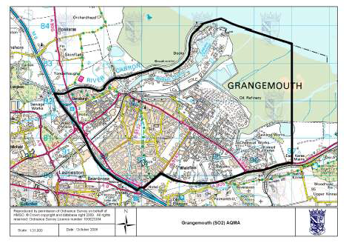
An AQMA was declared in Banknock in August 2011 in relation to breaches of the Scottish
and potential breaches of the UK PM₁₀ objectives, see Figure 1.1d.

An update on all AQMAs and where appropriate Action Plans is given in Section 8.

Figure 1.1 Maps of AQMA Boundaries in the Falkirk Council area.
a.) Grangemouth AQMA (15-minute SO₂), declared November 2005.

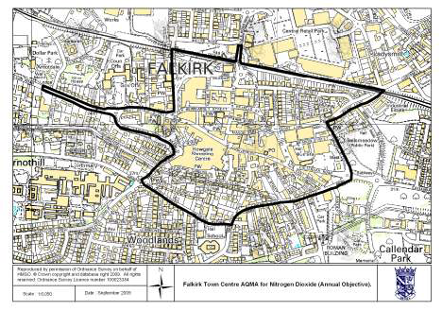
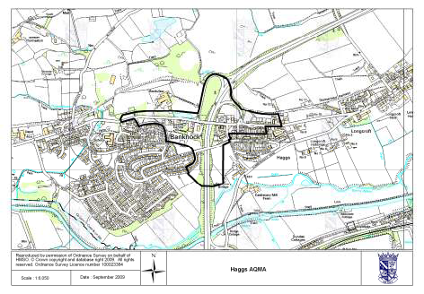
- Falkirk Town Centre AQMA (annual NO₂), declared March 2010.

- Haggs AQMA (annual NO₂), declared March 2010.

- Banknock AQMA (PM₁₀), declared August 2011.
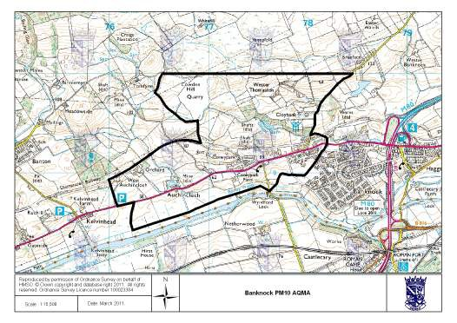

New Monitoring Data

Summary of Monitoring Undertaken

Automatic Monitoring Sites
In 2014 Falkirk Council operated automatic monitoring stations at 11 locations from Banknock in the west to Bo’ness in the east. The automatic monitoring measured PM_{2.5}, PM₁₀, NO₂ and SO₂. Table 2.1 provides a summary of all the automatic monitoring sites.

Falkirk Council operates two sites that are affiliated to the UK Automatic Urban and Rural Network (AURN): the Grangemouth AURN site (NO_{x}, SO₂, PM₁₀*, PM_{2.5}* and a pumped benzene diffusion tube*) and the Grangemouth Moray site (NO_{x} only). The AURN data forms part of the UK’s reporting to the EU in terms of compliance with the European objectives.

In 2014 the remaining analyser at the Grangemouth Moray site (SO₂) and six other monitoring sites (Banknock 2, Falkirk Hope St, Falkirk Park St, Falkirk West Bridge St, Grangemouth MC and Haggs) were affiliated to the Scottish Air Quality Network (SAQN). The remaining sites (Banknock 3, Bo’ness and Falkirk Grahams Road) are not affiliated to either network. The details of the network affiliation and QA / QC of each monitoring site and analyser are shown in the Appendix, Table A2.

The following changes have been made to the automatic monitoring network since the 2014 Progress Report:
      - Banknock 2 (A13): The TEOM was replaced by a FIDAS 200 in February 2015. This analyser measures PM₁₀ and PM_{2.5}. The latter is being measured primarily to assist with source identification at the site.
      - Falkirk West Bridge St (A7): The enclosure and NO_{x} analyser were replaced in January 2015. It is anticipated that the replacement will improve the data capture of the NO_{x} analyser.
      - Main St, Bainsford: A new enclosure has been located along this street to contribute towards the Detailed Assessment in the area. The NO_{x} and PM₁₀ (TEOM) analyser were re%located from the former Falkirk Park St site and commenced operation in June 2015.
      - Grangemouth Zetland Park: The Falkirk Park St enclosure and SO₂ analyser have been re%located to a new location in Zetland Park, Grangemouth. The analyser was commissioned in May 2015.

There are no outstanding changes to the automatic monitoring network.

* Scottish Government owned analysers.

Table 2.1 Details of Automatic Monitoring Sites

Site Number and Name | Site Type | OS Grid Ref |  | Pollutants Monitored | Technique / Equipment  Supplier | In AQMA? | Relevant exposure? | Distance to kerb of  road, m. | Represent worst-case  exposure?
A3. Bo’ness | Urban background /  industrial. | 299815 | 681481 | SO₂ | Horiba | N | Y (5 m) | 22 m * | N #
A4. Falkirk Haggs | Roadside. | 278977 | 679271 | NO₂, PM₁₀ | NO_{x}: ML, PM₁₀:  TEOM. | Y (NO₂) | Y (5 m) | 2 m | Y
A5. Falkirk Hope St | Roadside. | 288688 | 680218 | NO₂, SO₂. | Horiba. | Y (NO₂ and  PM₁₀.) | Y (1 m) | 5 m | N @ #
A6. Falkirk Park St | Roadside. | 288892 | 680070 | NO₂, SO₂, PM₁₀. | NO_{x} and SO₂: Horiba, PM₁₀:  TEOM. | Y (NO₂ and PM₁₀.) | Y (1 m) | 5 m | Y
A7. Falkirk West Bridge St | Roadside. | 288457 | 680064 | NO₂, PM₁₀ | NO_{x}: ML, PM₁₀: TEOM. | Y (NO₂ and  PM₁₀.) | Y (1 m) | 2 m | Y
A8. Grangemouth AURN (Inchyra Park) | Urban background / industrial. | 293830 | 681022 | Benzene, NO₂, PM₁₀, PM_{2.5}, SO₂. | Benzene (pumped tube), PM: FDMS.  NO_{x} and SO₂: ML. | Y (SO₂) | Y (5 m) | 20 m | Y
A9. Grangemouth Moray | Urban background /  industrial. | 293469 | 681321 | NO₂, SO₂. | NO_{x}: ML and SO₂: Horiba. | Y (SO₂) | Y (1 m) | 25 m | Y
A10.Grangemouth Municipal Chambers | Urban background / industrial. | 292816 | 682009 | NO₂, SO₂, PM₁₀. | NO_{x} and SO₂: Horiba, PM₁₀:  TEOM. | Y (SO₂) | Y (1 m) | 40 m | Y
A12. Falkirk Grahams Rd | Roadside. | 288823 | 680242 | PM₁₀ | TEOM. | Y (NO₂ and  PM₁₀.) | Y (1 m) | 10 m | N
A13. Banknock 2 | Roadside. | 277247 | 679027 | PM₁₀ | 2014: TEOM,  from 2015: Fidas | Y (PM₁₀) | Y (7 m) | 3 m | N
A14. Banknock 3 | Urban  background. | 277168 | 679254 | PM₁₀ | Osiris | Y (PM₁₀) | Y (19 m) | 17 m * | N #
Note: * Stated but not relevant to the pollutant and / or reason for monitoring.
# Location not designed to represent worst case exposure but to confirm boundaries of AQMA or is a background monitor. @ Distances to relevant exposure may not apply to all pollutants, due to shorter time period for SO₂.

Non-Automatic Monitoring Sites
In 2014 Falkirk Council monitored nitrogen dioxide at 63 locations, benzene at 16 locations and 1,3 butadiene at three locations using non%automatic methods, i.e. diffusion tubes. Table
  - provides details of the non%automatic monitoring sites. The diffusion tubes achieved good data capture across the year with very few tubes not achieving the annual data capture target of 75%. In addition, a pumped benzene diffusion tube (Defra / DA equipment) continued to operate at the Grangemouth AURN (A8) site as part of the AURN non% automatic hydrocarbon network. The details of the tubes used and the QA / QC of non% automatic monitoring are given in the Appendix A.

The following non%automatic site has ceased operation since the 2014 Progress Report:
- NA 47 (NO₂) Thistle Avenue, Grangemouth: background site no longer required.
- NA 70 (NO₂) Park St AQ station, Falkirk: This automatic monitoring site ceased in April 2014 therefore the diffusion tubes were discontinued.
- NA90 (NO₂) Grahams Rd bridge east, Falkirk: adequate coverage in the area with NA89 Grahams Rd / Meeks Rd.

The following non%automatic sites have commenced operation since the 2014 Progress Report.
- NA 110 (NO₂) Banknock 2 AQ station: To provide a supplementary NO₂ measurement to the Banknock PM₁₀ AQMA.
- NA 111 (NO₂) Falkirk West Bridge St AQ station: This triplicate study has replaced the roadside study conducted at the Falkirk Park St site.
- NA 112 (NO₂) Philip St, Bainsford: This will act as a background site for Main St, Bainsford.

The diffusion tubes NA110 and NA111 are co%located with the automatic monitoring sites and a map of NA112 is shown in Figure 2.1.

In 2014 Falkirk Council carried out three triplicate studies. This involves three NO₂ diffusion tubes being co%located with an automatic monitoring station. This enables the diffusion tube results to be bias adjusted. This is conducted to account for the difference between results from an automatic monitor and the diffusion tubes. The first study was located at the Grangemouth MC site (NA42 / A10), an urban background site. The second study at the Falkirk Park St site (NA70 / A6), a roadside site and finally a third study at Falkirk West Bridge St (NA111 / A7). However, the Falkirk Park St monitoring site, and therefore the triplicate study, ceased in April 2014. The replacement roadside study commenced at Falkirk West Bridge St in July 2014.

The results from the three sites were submitted to the R&A bias factor for ESG Didcot, however, Falkirk Park St and West Bridge St did not contribute to this factor because of the short monitoring periods. The bias sheet from Grangemouth MC and the R&A helpdesk summary are shown in Figures A2 and A3.

The local and R&A Helpdesk bias adjustment factors suggest that the diffusion tubes over% read NO₂ compared to the automatic monitors. Falkirk Council has applied the R&A helpdesk factor to the 2014 results because there are a mixture of roadside and background sites and no valid local roadside bias factor was available in 2014. The R&A bias factor for the ESG Didcot tubes in 2014 was 0.81. Note the data submitted to the R&A Helpdesk was provisional between July and December as the data is compiled prior to ratification. The ratification of the automatic monitoring data does not usually change the bias factor significantly.

Figure 2.1 Map of the new Non-Automatic Monitoring Site (NA112, Philip St, Bainsford).
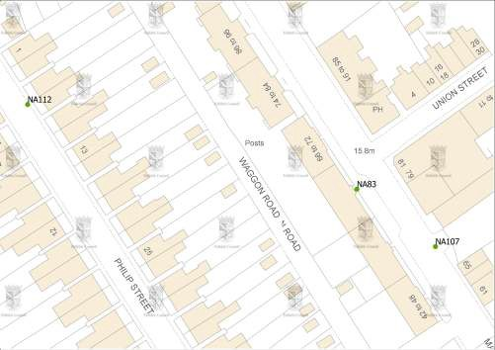

Table 2.2 Details of Non-Automatic Monitoring Sites

Site | Location | Site Type | OS Grid Ref (x, y) |  | Pollutants Monitored | In NO₂, benzene or  1,3 butadiene AQMA? | Relevant exposure?  (m) | Distance to kerb (nearest  road), m. | Worst-case Location?
NA3 | Tinto Drive, Grangemouth. | Urban  background. | 293427 | 680386 | Benzene, NO_{2.} | N | Y (<5) | <10 | N
NA5 | Copper Top pub,  Camelon. | Roadside. | 287332 | 680333 | NO₂. | N | Y (<2) | 0.6 (traffic  island) | Y
NA7 | Irving Parish Church,  Camelon. | Urban  background. | 287324 | 680442 | NO₂. | N | Y (<5) | <10 | N
NA9 | Bellsdyke Rd, Larbert. | Roadside. | 286048 | 683542 | NO₂. | N | Y (<2) | 0.7 | Y
NA19 | Kilsyth Rd, Banknock. | Roadside. | 278779 | 679301 | NO₂. | Y (NO₂). | Y (<2) | 2.2 | Y
NA20 | Garngrew Rd, Haggs. | Urban  background. | 278975 | 679172 | NO₂. | N | Y (<5) | <10 | N
NA21 | Grangemouth Rd, College. | Roadside. | 290112 | 680500 | Benzene, NO₂. | N | Y (<2) | 1.8 | Y
NA24 | Kerse Lane, Falkirk. | Roadside. | 289187 | 680024 | NO₂. | Y (NO₂). | Y (<2) | 3 | Y
NA26 | Weir St, Falkirk. | Urban  background. | 289207 | 680123 | NO₂. | Y (NO₂). | Y (<5) | <10 | N
NA27 | West Bridge St, Falkirk. | Roadside. | 288490 | 680055 | Benzene, NO₂. | Y (NO₂). | Y (<2) | 0.5 | Y
NA29 | Wellside Place, Falkirk. | Urban  background. | 288465 | 680220 | NO₂. | N | Y (<5) | <10 | N
NA36 | Kerr Crescent, Haggs. | Roadside. | 278985 | 679273 | NO₂. | Y (NO₂). | Y (<5) | 2.1 | N
NA37 | Denny Town House. | Urban centre. | 281226 | 682526 | Benzene, NO₂. | N | Y (<5) | <5 | Y
NA38 | Larbert Village Primary  School. | Urban  background. | 285930 | 682318 | Benzene, NO₂. | N | Y (<5) | <10 | N
NA41 | Seaview Place, Bo’ness. | Roadside. | 299722 | 681594 | Benzene, 1,3 Butadiene, NO₂. | N | Y (<2) | 0.1 | Y
NA42 | Municipal Chambers, Grangemouth. | Urban centre / industrial. | 292817 | 682000 | Benzene, NO₂*. | N | Y (<5) | <10 | Y

Table 2.2 Details of Non-Automatic Monitoring Sites continued

Site | Location | Site Type | OS Grid Ref (x, y) |  | Pollutants Monitored | In NO₂, benzene or  1,3 butadiene AQMA? | Relevant exposure?  (m) | Distance to kerb (nearest  road), m. | Worst-case Location?
NA44 | Greenpark Drive, Polmont. | Urban  background. | 293436 | 678938 | Benzene, NO₂. | N | Y (<5) | <10 | N
NA48 | Hayfield, Falkirk. | Urban  background. | 289200 | 681580 | NO₂. | N | Y (<5) | <10 | N
NA50 | Upper Newmarket St,  Falkirk. | Urban  background. | 288671 | 680047 | NO₂. | Y (NO₂). | Y (<5) | <10 | N
NA51 | Mary St, Laurieston. | Roadside. | 290965 | 679490 | NO₂. | N | Y (1) | 4.5 | Y
NA52 | Main St, Larbert. | Roadside. | 285866 | 682356 | NO₂. | N | Y (<2) | 4.4 | Y
NA53 | Denny Cross. | Roadside. | 281211 | 682727 | NO₂. | N | Y (<2) | 0.8 | Y
NA55 | Inchyra Station. | Urban background /  industrial. | 293830 | 681022 | Benzene, 1,3 butadiene. | N | Y (<5) | <2 | N
NA57 | Inchyra Road, Grangemouth. | Urban background /  industrial. | 294028 | 680829 | Benzene, NO₂. | N | Y (<5) | <10 | Y
NA58 | Callendar Rd, Falkirk. | Roadside. | 289667 | 679724 | NO₂. | N | Y (<2) | 0.5 | Y
NA59 | Carron Rd, Bainsford. | Roadside. | 288392 | 681931 | NO₂. | N | Y (<2) | 1.2 | Y
NA60 | Ronades Rd, Carron. | Roadside. | 288133 | 681587 | NO₂. | N | Y (<2) | 1.6 | Y
NA61 | Canal Rd, Falkirk. | Roadside. | 287976 | 680656 | NO₂. | N | Y (<2) | 1.5 | Y
NA62 | Arnot St, Falkirk. | Roadside. | 289125 | 679705 | NO₂. | Y (NO₂). | Y (<2) | 1.2 | Y
NA63 | Camelon Rd, Falkirk. | Urban  background. | 288055 | 680134 | NO₂. | On boundary NO₂. | Y (<5) | <10 | N
NA64 | New Hallglen Rd, Falkirk. | Roadside. | 288807 | 678422 | NO₂. | N | Y (<2) | 1.7 | Y
NA65 | Redding Rd, Redding. | Roadside. | 291356 | 678644 | NO₂. | N | Y (<2) | 0.6 | Y

Table 2.2 Details of Non-Automatic Monitoring Sites continued

Site | Location | Site Type | OS Grid Ref (x, y) |  | Pollutants Monitored | In NO₂, benzene or  1,3 butadiene AQMA? | Relevant exposure?  (m) | Distance to kerb (nearest  road), m. | Worst-case Location?
NA67 | Queen St, Falkirk. | Urban  background. | 289430 | 680433 | NO₂. | N | Y (<5) | <10 | N
NA68 | Bellevue St, Falkirk. | Roadside. | 289234 | 679945 | NO₂. | Y (NO₂). | Y (<2) | 1.7 | Y
NA69 | Kerse Lane, Falkirk. | Roadside. | 289025 | 679991 | NO₂. | Y (NO₂). | Y (<2) | 2.3 | Y
NA70 | Park St AQ station,  Falkirk. | Roadside. | 288892 | 680070 | NO₂.* | Y (NO₂). | Y (<2) | 4.7 | Y
NA71 | Park St, Falkirk. | Roadside. | 288910 | 680112 | NO₂. | Y (NO₂). | Y (<2) | 1.5 | Y
NA72 | Vicar St, Falkirk. | Roadside. | 288824 | 680120 | NO₂. | Y (NO₂). | Y (<2) | 1.5 | Y
NA73 | West Bridge St RHS,  Falkirk. | Roadside. | 288467 | 680048 | NO₂. | Y (NO₂). | Y (<2) | 0.3 | Y
NA76 | Tyrst Road,  Stenhousemuir. | Roadside. | 286851 | 683229 | NO₂. | N | Y (<2) | <2 | Y
NA77 | Kinnaird Village. | Roadside. | 286490 | 683775 | Benzene, NO₂. | N | Y (<2) | 3.9 | Y
NA78 | Glen Brae, Falkirk. | Roadside. | 288525 | 678991 | NO₂. | N | Y (<2) | 2.6 | Y
NA80 | Cow Wynd, Falkirk. | Roadside. | 288765 | 679456 | Benzene, NO₂. | N | Y (<2) | 1.8 | Y
NA81 | Grahams Rd, Falkirk. | Roadside. | 288834 | 680898 | Benzene, NO₂. | N | Y (<2) | 0.5 | Y
NA82 | Castings Ave, Falkirk. | Roadside. | 288858 | 681036 | NO₂. | N | Y (<2) | <2 | Y
NA83 | Main St, Bainsford. | Roadside. | 288614 | 681415 | NO₂. | N | Y (<2) | 0.5 | Y
NA85 | Auchinloch Dr, Banknock. | Roadside. | 278752 | 679049 | NO₂. | Y (NO₂). | Y (<2) | <2 | Y
NA86 | Wolfe Rd, Falkirk. | Urban  background. | 289667 | 679871 | NO₂. | N | Y (<2) | 2 | N
NA87 | M80 slip south, Haggs. | Roadside. | 279017 | 679305 | NO₂. | Y (NO₂). | Y (<2) | 1.6 | Y

Table 2.2 Details of Non-Automatic Monitoring Sites continued

Site | Location | Site Type | OS Grid Ref (x, y) |  | Pollutants Monitored | In NO₂, benzene or  1,3 butadiene AQMA? | Relevant exposure?  (m) | Distance to kerb (nearest  road), m. | Worst-case Location?
NA88 | Ure Crescent,  Bonnybridge. | Roadside. | 282444 | 681074 | NO₂. | N | Y (<2) | 1.7 (16 to  M876) | Y
NA89 | Grahams Rd/Meeks Rd,  Falkirk. | Roadside. | 288853 | 680328 | NO₂. | N | Y (<2) | 2.2 | Y
NA94 | A905 (Glensburgh Rd),  Grangemouth. | Roadside. | 291213 | 681927 | Benzene, NO₂. | N | Y (7) | 5.4 | Y
NA98 | Arnothill, Falkirk | Urban  background. | 288095 | 680105 | NO_{2.} | N | Y (23) | 1.6 | N
NA99 | St Crispins Place, Falkirk | Roadside. | 288924 | 679675 | NO_{2.} | Y (NO₂). | Y (7.6) | 2.7 | Y
NA100 | Oswald St, Falkirk | Urban  background. | 288977 | 679662 | NO_{2.} | N | Y (3.8) | 1.5 | N
NA101 | Glensburgh Road (2),  Grangemouth | Roadside. | 291127 | 682007 | NO_{2.} | N | Y (7) | 0.9 | Y
NA102 | East Kerse Mains, Bo'ness | Urban  background. | 297968 | 680684 | Benzene | N | N | 23 (main road) | N
NA103 | Merchiston Gardens | Urban  background. | 288270 | 680989 | NO_{2.} | N | Y (12.5) | 1.6 | N
NA104 | Powdrake Road, Grangemouth | Urban  background / industrial. | 293788 | 682054 | 1,3 butadiene | N | Y (40) | 1.8 | Y
NA105 | West of Shieldhill | Rural. | 288292 | 676889 | Benzene, NO_{2.} | N | N | 1.7 | N

Table 2.2 Details of Non-Automatic Monitoring Sites continued

Site | Location | Site Type | OS Grid Ref (x, y) |  | Pollutants Monitored | In NO₂, benzene or  1,3 butadiene AQMA? | Relevant exposure?  (m) | Distance to kerb (nearest  road), m. | Worst-case Location?
NA107 | Main Street (east),  Bainsford | Roadside. | 288640 | 681396 | NO_{2.} | N | Y (4) | 0.5 | Y
NA108 | Main Street, Camelon | Roadside. | 286834 | 680512 | NO_{2.} | N | Y (4) | 7 | Y
NA109 | Carmuirs Street, Camelon | Urban  background. | 286786 | 680488 | NO_{2.} | N | Y (4) | 44 | N
NA110 | Banknock 2 AQ station | Roadside. | 277247 | 679027 | NO_{2.} | N | Y (3) | 7 | Y
NA111 | Falkirk West Bridge St AQ  station | Roadside. | 288457 | 680064 | NO2. * | Y (NO₂). | Y (21) | 3 | Y
NA112 | Philip Street, Bainsford | Urban  background. | 288505 | 681443 | NO_{2.} | N | Y (4) | 1 | N

* Triplicate study carried out at this site.

Comparison of Monitoring Results with Air Quality Objectives

Nitrogen Dioxide

Automatic Monitoring Data
In 2014 the Falkirk West Bridge St site breached the annual NO₂ objective recording a concentration of 41.3 Gg/m³. This is a slight increase of 2.1 Gg/m³ from the 2013 monitoring result. With the data capture being only marginally below the 90% data capture requirement at 89.2% the annual result has not been annualised.

The other six NO₂ analysers in Falkirk Council’s automatic network met both of the nitrogen dioxide (NO₂) objectives. The Haggs (A4) monitoring site continues to record NO₂ concentrations within the objective. There were no hourly exceedances at any of the monitoring sites and thus the hourly objective was met at all the sites. All the results are shown in Tables 2.3 and 2.4.

Figure 2.2 shows long terms trends for the Grangemouth AURN, Haggs and Falkirk West Bridge St sites. There is a slight downward trend in NO₂ concentrations at the background Grangemouth AURN site between 2001 and 2015. However, a significant decrease has been recorded at the Haggs site compared to both the peak in 2010 and the concentrations recorded in 2009. This is likely to have occurred because of the completion of the M80 and a reduced speed limit of 30 mph on the A803 which has transferred traffic from the local to trunk road network. In addition, NO₂ concentrations have reduced at background sites (eg. Grangemouth MC and Moray) since 2012.

Table 2.3 Results of Automatic Monitoring of Nitrogen Dioxide: Comparison with Annual Mean Objective (40 Bg/m³).

Site | Location | Within NO₂  AQMA? | Data  Capture 2014, % | Annual Mean Concentration Bg/m³
 |  |  |  | 2011 | 2012 | 2013 | 2014
A4 | Falkirk Haggs | Y | 93.7 | 34.4 | 35.9 | 34.2 * | 32.1
A5 | Falkirk Hope St | Y | 99.8 | 24.1 | 25.1 | 23 | 23.4
A6 | Falkirk Park St | Y | 32.0 | 28.5 | 33.2 | 30.4 | 28 * #
A7 | Falkirk West Bridge  St | Y | 89.2 | 35.9 * # | 43.4* | 39.2 | 41.3
A8 | Grangemouth  AURN | N | 95.3 | 15.1 | 16.2 | 14.5 | 16.3
A9 | Grangemouth  Moray | N | 92 | 17.3 | 19.6 | 16.6 | 15.4
A10 | Grangemouth MC | N | 99.1 | 21.6 | 24.1 | 20.2 | 19.6

* Annual data capture less than 90%. # Result has been annualised.

Table 2.4 Results of Automatic Monitoring for Nitrogen Dioxide: Comparison with 1-hour mean Objective (18 exceedances of 200 Bg/m³).

Site | Location | Within NO₂ AQMA? | Data Capture 2014, % | Number of Exceedances of Hourly Mean  (200 Bg/m³), (99.8th percentile in brackets).
 |  |  |  | 2011 | 2012 | 2013 | 2014
A4 | Falkirk Haggs | Y | 93.7 | 0 (142) | 0 (141) | 0 (138) | 0 (127)
A5 | Falkirk Hope St | Y | 99.8 | 0 (111) | 0 (133) | 0 (94) | 0 (86)
A6 | Falkirk Park St | Y | 32 | 0 (97) | 0 (107) | 0 (98) | 0 (90)
A7 | Falkirk West Bridge  St | Y | 89.2 | 0 (113) * | 0 (124) * | 0 (120) | 0 (123)
A8 | Grangemouth  AURN | N | 95.3 | 0 (78) | 0 (92) | 0 (80) | 0 (72)
A9 | Grangemouth  Moray | N | 92 | 0 (84) | 0 (86) | 0 (78) | 0 (66)
A10 | Grangemouth MC | N | 99.1 | 0 (86) | 0 (103) | 0 (83) | 0 (75)

* Annual data capture less than 90%.

Figure 2.2 Trends in Nitrogen Dioxide Concentrations (deseasonalised) at three Automatic Monitoring Sites, a.) Grangemouth AURN,
b.) Falkirk West Bridge St and c.) Haggs. Reference 1.
a.)
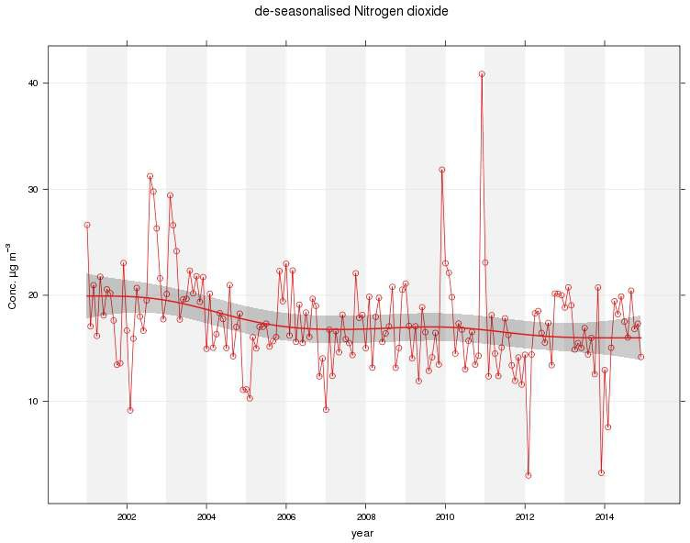

b.)
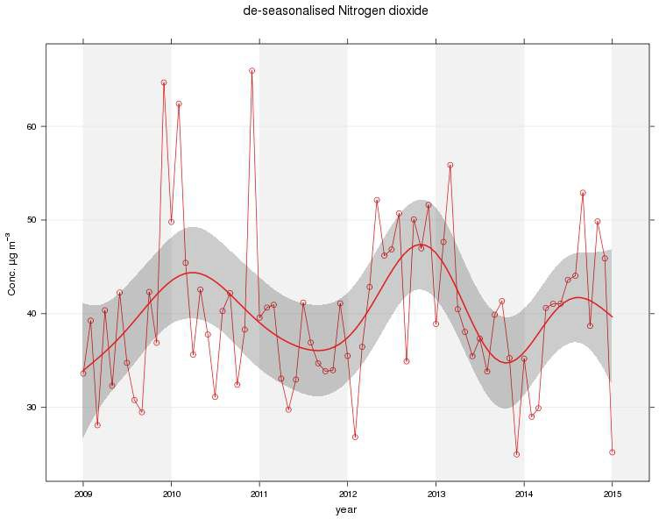

c.)
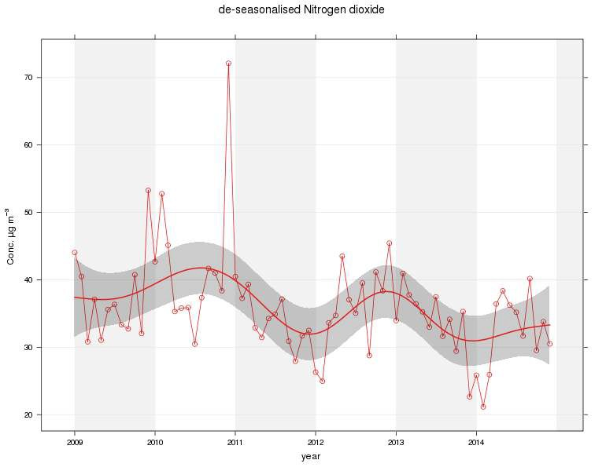

Diffusion Tube Monitoring Data
Table 2.6 shows the annual NO₂ concentrations in 2014 of Falkirk Council’s diffusion tubes, and the previously reported results between 2011 and 2013. The diffusion tube results have been annualised for the sites that operated over the duration of 2014 but recorded data capture below 75% and those tubes that started operation part way through the year. None of the results in Table 2.6 have been distance corrected as this is carried out as appropriate. Figure 2.4 shows the results on a map across the Falkirk and Haggs AQMAs.

The following diffusion tubes recorded a concentration greater than the annual NO₂ objective of 40 Gg/m³ in 2014 with the application of the R&A bias factor:
- NA27 West Bridge St, Falkirk: this site is in the Falkirk Town Centre AQMA and is close to the Falkirk West Bridge St site (A7). The automatic monitoring site recorded a similar breach of the objective, all be it, with a lower concentration as it is slightly further from the kerb.

The following diffusion tubes recorded a concentration close to the objective (36 to 40 Gg/m³) in 2014 with the application of the R&A bias factor:
- NA19 Kilsyth Road, Banknock: this site is in the Haggs AQMA.
- NA24 Kerse Lane, Falkirk: this site is in the Falkirk Town Centre AQMA.
- NA36 Kerr Crescent, Haggs: this site in the Haggs AQMA.
- NA62 Arnot Street, Falkirk: this site is in the Falkirk Town Centre AQMA.
- NA63 Camelon Road, Falkirk: this site in on the boundary of the Falkirk Town Centre AQMA.
- NA68 Bellevue St, Falkirk: this site is in the Falkirk Town Centre AQMA.

There is no local roadside bias factor in 2014 to adjust the diffusion tube results because of the closure of the Falkirk Park St monitoring site. A new triplicate study commenced at Falkirk West Bridge St in July 2014 but with less than nine months of diffusion tube data a bias factor cannot be calculated.

The diffusion tube monitoring indicates that NO₂ concentrations have decreased compared to 2013. A comparison in Figure 2.3 of the monthly average concentrations across all of Falkirk’s diffusion tubes, with respective bias factors applied, indicate that levels were substantially lower during 2014 between January and April and in June in comparison to 2013. During the other months concentrations were only slightly different across the two years.

Note in April 2014 the contractor that supplies and analyses the 1,3 butadiene tubes changed from Environmental Scientifics Group to Gradko and in April 2015 a similar change occurred with the NO₂ and benzene diffusion tubes.

Figure 2.3 Monthly average NO₂ concentrations at all diffusion tube sites in 2013 and 2014.

Average monthly NO2 concentrations acrossall sites, 2013 and 2014.
50
45
40
35
30
25 2013
20 2014
15
10
5
0
an Feb Mar April May une uly Aug Sept Oct Nov Dec

The concentrations recorded by the diffusion tubes have, on average, decreased between 2011 and 2014 (Table 2.5). Although site dependent the decrease is not as strongly reflected at some of the automatic monitoring sites.

The R&A factor was greater than the local roadside site factor (0.76 local road and 0.84 R&A) in 2011, while in 2012 and 2013 the local roadside factor was greater than the R&A (0.86 and 0.87 local road compared to 0.79 and 0.80 R&A). This may explain why the NO₂ diffusion tubes show a greater decrease between 2011 and 2014. However, the decrease is less substantial when considering 2012 to 2014 data and this decline ties in with more automatic monitoring sites.

There is no local roadside bias factor in 2014 due to the closure of the Falkirk Park St monitoring site. A triplicate study at Falkirk West Bridge St commenced in July 2014 but nine months of data is required to calculate a bias factor. This will be available in 2015 and will ensure that any roadside tubes that are close to the objective can be considered with a local roadside factor and the R&A factor.

Table 2.5 Average NO₂ concentrations across all NO₂ diffusion tubes.

Average NO2, Bg/m3, concentrations |  |  |  | across all sites.
Type of site | 2011  (0.84) | 2012  (0.79) | 2013  (0.80) |  | 2014  (0.81)
All | 30.5 | 28.7 | 27.3 |  | 25.7
Road and  kerbside | 33.0 | 31.6 | 29.9 |  | 28.3
Non%  road/kerbside | 23.1 | 21.9 | 21.1 |  | 19.4

Table 2.6 Results of Nitrogen Dioxide Diffusion Tubes in 2014.

Site | Location | Within NO₂ AQMA? | Data Capture for Monitoring Period, % | Data Capture 2014, % | Annual mean concentrations, Bg/m³
 |  |  |  |  | 2011  (0.84) | 2012  (0.79) | 2013  (0.80) | 2014  (0.81)
NA3 | Tinto Drive,  Grangemouth. | N | n/a | 100 | 21 | 21 | 21 | 19
NA5 | Copper Top pub,  Camelon. | N | n/a | 100 | 31 | 31 | 28 | 27
NA7 | Irving Parish Church,  Camelon. | N | n/a | 100 | 21 | 19 | 19 | 18
NA9 | Bellsdyke Rd, Larbert. | N | n/a | 100 | 28 | 25 | 26 | 29
NA19 | Kilsyth Rd, Banknock. | Y | n/a | 67 | 33 * | 36 | 36 | 36
NA20 | Garngrew Rd, Haggs. | N | n/a | 75 | 25 | 27 | 24 | 22
NA21 | Grangemouth Rd,  College. | N | n/a | 92 | 33 | 30 | 28 | 28
NA24 | Kerse Lane, Falkirk. | Y | n/a | 100 | 40 | 37 | 42 | 37
NA26 | Weir St, Falkirk. | Y | n/a | 100 | 22 | 22 | 21 | 18
NA27 | West Bridge St,  Falkirk. | Y | n/a | 100 | 51 | 61 | 53 | 45
NA29 | Wellside Place,  Falkirk. | N | n/a | 100 | 21 | 20 | 18 | 17
NA36 | Kerr Crescent, Haggs. | Y | n/a | 100 | 47 | 42 | 40 | 38
NA37 | Denny Town House. | N | n/a | 100 | 20 | 20 | 19 | 20
NA38 | Larbert Village Primary  School. | N | n/a | 100 | 21 | 20 | 19 | 18
NA41 | Seaview Place,  Bo’ness. | N | n/a | 100 | 25 | 24 | 22 | 21
NA42 | Municipal Chambers,  Grangemouth. | N | n/a | 100 | 22 | 21 | 20 | 19
NA44 | Greenpark Drive,  Polmont. | N | n/a | 92 | 17 * | 17 | 16 | 16

Table 2.6 Results of Nitrogen Dioxide Diffusion Tubes in 2014 continued

Site | Location | Within NO₂ AQMA? | Data Capture for Monitoring Period, % | Data Capture 2014, % | Annual mean concentrations, Bg/m³
 |  |  |  |  | 2011  (0.84) | 2012  (0.79) | 2013  (0.80) | 2014  (0.81)
NA48 | Hayfield, Falkirk. | N | n/a | 100 | 22 | 21 | 21 | 20
NA50 | Upper Newmarket St,  Falkirk. | Y | n/a | 100 | 26 | 30 | 30 | 27
NA51 | Mary St, Laurieston. | N | n/a | 100 | 30 | 27 | 24 | 25
NA52 | Main St, Larbert. | N | n/a | 100 | 30 | 28 | 26 | 21
NA53 | Denny Cross. | N | n/a | 100 | 33 | 34 | 33 | 31
NA57 | Inchyra Road,  Grangemouth. | N | n/a | 100 | 28 | 27 | 26 | 26
NA58 | Callendar Rd, Falkirk. | N | n/a | 100 | 23 | 23 | 22 | 21
NA59 | Carron Rd, Bainsford. | N | n/a | 100 | 32 | 31 | 28 | 26
NA60 | Ronades Rd, Carron. | N | n/a | 100 | 31 | 29 | 29 | 27
NA61 | Canal Rd, Falkirk. | N | n/a | 92 | 30 | 25 | 26 | 25
NA62 | Arnot St, Falkirk. | Y | n/a | 100 | 43 | 39 | 36 | 38
NA63 | Camelon Rd, Falkirk. | On boundary NO₂. | n/a | 100 | 42 | 41 | 38 | 36
NA64 | New Hallglen Rd,  Falkirk. | N | n/a | 100 | 20 | 20 | 20 | 18
NA65 | Redding Rd, Redding. | N | n/a | 92 | 24 | 25 | 24 | 18
NA67 | Queen St, Falkirk. | N | n/a | 100 | 33 | 31 | 31 | 28
NA68 | Bellevue St, Falkirk. | Y | n/a | 100 | 36 | 35 | 31 | 29
NA69 | Kerse Lane, Falkirk. | Y | n/a | 100 | 35 | 38 | 33 | 35
NA70 | Park St AQ station,  Falkirk. | Y | 100 | 33 | 32 | 30 | 28 | 28

Table 2.6 Results of Nitrogen Dioxide Diffusion Tubes in 2014 continued

Site | Location | Within NO₂ AQMA? | Data Capture for Monitoring  Period, % | Data Capture  2014, % | Annual mean concentrations, Bg/m³
 |  |  |  |  | 2011  (0.84) | 2012  (0.79) | 2013  (0.80) | 2014  (0.81)
NA71 | Park St, Falkirk. | Y | n/a | 92 | 41 | 38 | 35 | 33
NA72 | Vicar St, Falkirk. | Y | n/a | 100 | 34 | 33 | 33 | 32
NA73 | West Bridge St RHS,  Falkirk. | Y | n/a | 92 | 37 | 34 | 35 | 33
NA76 | Tyrst Road,  Stenhousemuir. | N | n/a | 100 | 24 | 24 | 20 | 23
NA77 | Kinnaird Village. | N | n/a | 92 | 31 | 25 | 24 | 22
NA78 | Glen Brae, Falkirk. | N | n/a | 100 | 32 | 31 | 30 | 30
NA80 | Cow Wynd, Falkirk. | N | n/a | 75 | 33 | 31 | 29 | 30
NA81 | Grahams Rd, Falkirk. | N | n/a | 92 | 34 | 32 | 32 | 29
NA82 | Castings Ave, Falkirk. | N | n/a | 100 | 23 | 22 | 20 | 18
NA83 | Main St, Bainsford. | N | n/a | 100 | 44 | 41 | 37 | 34
NA85 | Auchinloch Dr,  Banknock. | Y | n/a | 100 | 25 | 25 | 23 | 21
NA86 | Wolfe Rd, Falkirk. | N | n/a | 100 | 18 | 19 | 19 | 15
NA87 | M80 slip south, Haggs. | Y | n/a | 100 | 36 | 33 | 32 | 32
NA88 | Ure Crescent,  Bonnybridge. | N | n/a | 100 | 36 | 33 | 30 | 29
NA89 | Grahams Rd/Meeks  Rd, Falkirk. | N | n/a | 83 | 37 | 34 | 34 | 30
NA94 | A905 (Glensburgh Rd),  Grangemouth. | N | n/a | 92 | 37 * | 38 | 36 | 31

Table 2.6 Results of Nitrogen Dioxide Diffusion Tubes in 2014 continued

Site | Location | Within NO₂ AQMA? | Data Capture for Monitoring  Period, % | Data Capture  2014, % | Annual mean concentrations, Bg/m³
 |  |  |  |  | 2011  (0.84) | 2012  (0.79) | 2013  (0.80) | 2014  (0.81)
NA98 | Arnothill, Falkirk | N | n/a | 67 | 26 * | 26 | 25 | 22
NA99 | St Crispins Place,  Falkirk | Y | n/a | 100 | 34 * | 29 | 26 | 25
NA100 | Oswald St, Falkirk | N | n/a | 92 | 22 * | 22 | 21 | 20
NA101 | Glensburgh Road (2),  Grangemouth | N | n/a | 92 | 28 * | 26 | 24 | 24
NA103 | Merchiston Gardens | N | n/a | 75 | 22 * | 21 | 19 | 16
NA105 | West of Shieldhill | N | n/a | 100 | 11 * | 10 | 10 | 9
NA107 | Main Street (east),  Bainsford | N | n/a | 100 | n/m | n/m | 31 | 30
NA108 | Main Street, Camelon | N | n/a | 100 | n/m | n/m | n/m | 23
NA109 | Carmuirs Street,  Camelon | N | n/a | 92 | n/m | n/m | n/m | 18 *
NA110 | Banknock 2 AQ station | N | 100 | 75 | n/m | n/m | n/m | 18 *
NA111 | Falkirk West Bridge St  AQ station | Y | 80 | 40 | n/m | n/m | n/m | 33 *
NA112 | Philip Street, Bainsford | N | 100 | 17 | n/m | n/m | n/m | 16 *

* Annual adjusted.

Figure 2.4 NO₂ diffusion tube monitoring results in a.) Falkirk Town Centre and b.) Haggs AQMAs. Green less than 36 Bg/m³, orange 36 to 40 Bg/m³ and red greater than 40 Bg/m³.
a.)
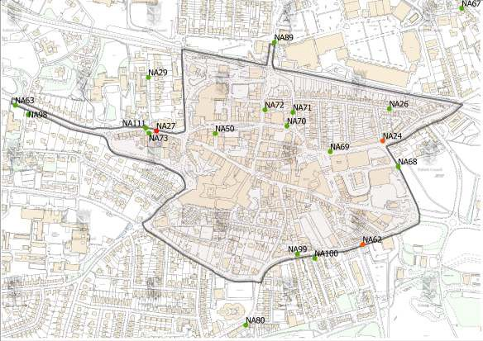

b.)
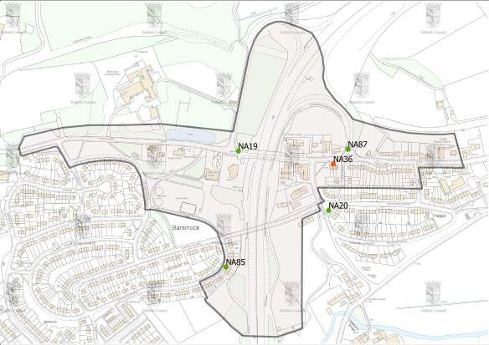

PM₁₀

Falkirk Council measured PM₁₀ concentrations at eight locations in 2014. The site with the greatest concentration, but within the Scottish annual PM₁₀ objective, was the Falkirk West Bridge St site with an annual average concentration of 17.7 Gg/m³. However, the site was slightly below the data capture target with 85% achieved in 2014. Two daily exceedances were recorded at the Falkirk West Bridge St site with the 98th percentile below the limit value at 40 Gg/m³.

The Banknock 2 monitoring site recorded the greatest number of daily exceedances (three), but again this is within the Scottish daily PM₁₀ objective. Thus the two sites within the Banknock AQMA (Banknock 2 and 3) met the Scottish PM₁₀ objectives in 2014.

All other sites met the Scottish PM₁₀ objectives in 2014. The UK / EU objectives were met at all sites in 2014. The full results are shown in Tables 2.7 and 2.8. The Banknock AQMA will remain in place because the Tomfyne quarry has been given planning permission but is subject to s75 and legal agreements before operations can commence.

It is noted that the Scottish Government has proposed in its draft Low Emissions Strategy that the particulate matter objectives are aligned with the World Health Organisation standards. The result of this would be an increase of the annual PM₁₀ objective from 18 to 20 Gg/m³ but a reduction of the PM_{2.5} objective from 12 to 10 Gg/m³. In addition, it was proposed that PM_{2.5} is included in Local Air Quality Management.

It is thus proposed that the Haggs AQMA is not amended to include PM₁₀. The concentration recorded in 2014 was 16.5 Gg/m³ (a decrease from the marginal breach in 2013 of 18.3 Gg/m³) and thus the site achieved both the existing 18 and potential future 20 Gg/m³ objectives. It is quite likely that the TEOM at the Haggs site will be converted to monitor PM_{2.5} in the future.

Figure 2.5 shows long%term trends of PM₁₀ concentrations at the Grangemouth AURN site and Falkirk West Bridge St site. The trend in PM₁₀ at the Grangemouth AURN site should be treated with slight caution as there have been changes to the correction factor used and the monitoring technique used. However, there is long%term decline at the monitoring site although the concentrations have levelled out since early 2009.

The Falkirk West Bridge St monitoring site has recorded a decline in concentrations between its installation in September 2009 and December 2014. This reflects well the annual concentrations recorded and reported in Tables 2.7 and 2.8.

Table 2.7 Results of Automatic Monitoring of PM₁₀: Comparison with Annual Mean Objectives (18 and 40 Bg/m³)

Site | Site Type | Within PM₁₀ AQMA? | Data Capture for Monitoring  Period, % | Data Capture 2014, % | Reference Equivalent  ? | Annual mean concentration, Bg/m³
 |  |  |  |  |  | 2011 | 2012 | 2013 | 2014
A4: Falkirk Haggs | Roadside | N | n/a | 96.9 | Y, VCM | n/m | 15.9* # | 18.3 | 16.5
A6. Falkirk Park St | Roadside. | Y | n/a | 31.8 | Y, VCM | 15.6 | 14.6 | 15.2 | 14.8 * #
A7. Falkirk West  Bridge St | Roadside. | Y | n/a | 85 | Y, VCM | 18.7 * # | 17.8 | 19.5 | 17.7 *
A8. Grangemouth AURN | Urban background /  industrial. | N | n/a | 95.8 | Y, FDMS | 14.1 | 14.1 | 14 * # | 12.4
A10.Grangemouth Municipal Chambers | Urban background /  industrial. | N | n/a | 93.2 | Y, VCM | 15.1 * # | 14.7 * # | 15 * # | 14.6
A12. Falkirk  Grahams Rd | Roadside | Y | n/a | 94.3 | Y, VCM | n/m | 16 | 16.3 | 13.2
A13. Banknock 2 | Roadside | Y | n/a | 98 | Y, VCM | n/m | 12.7 * # | 14.6 | 15
A14. Banknock 3 | Urban  background | Y | n/a | 82.1 | N, 1.14  Osiris | n/m | n/m | 12.3 * # | 10.6 *

* Annual data capture less than 90%.

Table 2.8 Results of Automatic Monitoring for PM₁₀: Comparison with 24-hour mean Objectives (7 and 35 exceedances of 50 Bg/m³)

Site | Site Type | Within PM₁₀ AQMA? | Data Capture for Monitoring  Period % | Data Capture 2014, % | Reference Equivalent? | Number of Daily Exceedances of 50 Bg/m³ (98th percentile)
 |  |  |  |  |  | 2011 | 2012 | 2013 | 2014
A4: Falkirk Haggs | Roadside | N | n/a | 96.9 | Y, VCM | n/m | 0 (45) * | 4 (46) | 1 (38)
A6. Falkirk Park St | Roadside. | Y | n/a | 31.8 | Y, VCM | 2 (38) | 2 (38) | 1 (34) | 0 (34) *
A7. Falkirk West  Bridge St | Roadside. | Y | n/a | 85 | Y, VCM | 5 (49) * | 6 (46) | 4 (49) | 2 (40) *
A8. Grangemouth AURN | Urban background /  industrial. | N | n/a | 95.8 | Y, FDMS | 2 (38) | 2 (37) | 0 (34) * | 0 (32)
A10.Grangemouth Municipal  Chambers | Urban background /  industrial. | N | n/a | 93.2 | Y, VCM | 0 (40) | 2 (41) * | 0 (32)* | 0 (34)
A12. Falkirk  Grahams Rd | Roadside | Y | n/a | 94.3 | Y, VCM | n/m | 4 (44) | 3 (38) | 0 (32)
A13. Banknock 2 | Roadside | Y | n/a | 98 | Y, VCM | n/m | 0 (18) * | 0 (33) | 3 (40)
A14. Banknock 3 | Urban  background | Y | n/a | 82.1 | N, 1.14  Osiris | n/m | n/m | 0 (22) * | 0 (24) *

* Annual data capture less than 90%.

Figure 2.5 Trends in PM₁₀ Concentrations at a.) Grangemouth AURN and b.) Falkirk West Bridge St. a.)
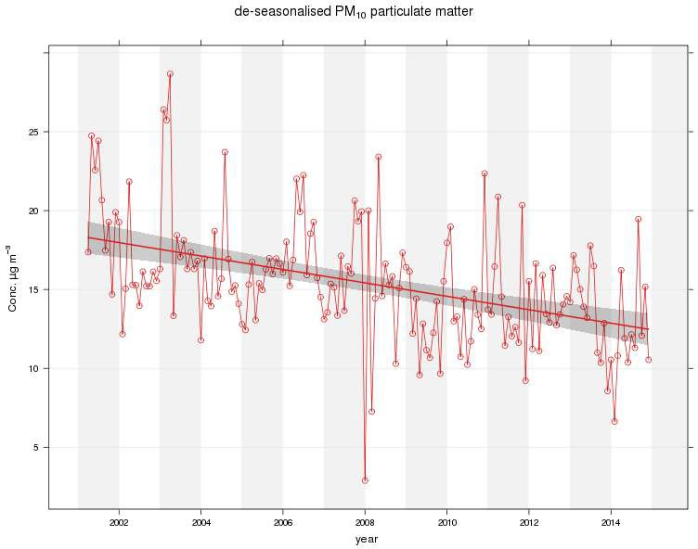

b.)
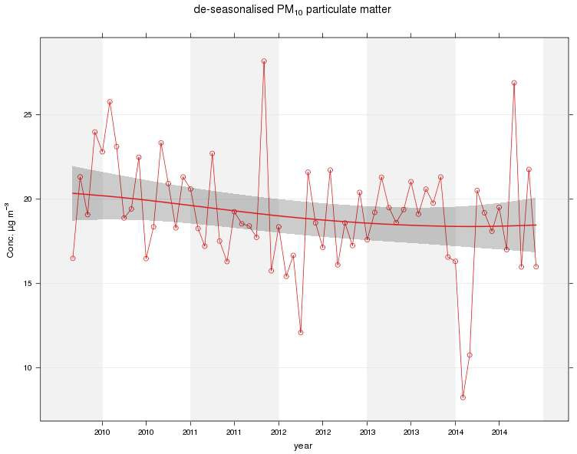

Sulphur Dioxide

In 2014 Falkirk Council monitored sulphur dioxide at six locations with the results shown in Table 2.9. The 15%minute objective was met at all six monitoring sites in 2014 with the daily and hourly standards (and therefore objectives) met. The monitoring results are consistent with the 2013 results and since the commissioning of the Tail Gas Unit at the refinery. All six monitoring sites achieved 90% data capture during their operational periods. The Falkirk Park St site achieved 99.4% period data capture but due to its closure only 17.4% annual data capture.

As reported in the 2014 Progress Report the Tail Gas Treatment abatement unit was commissioned by Petroineos in August 2013. In addition, Flue Gas Desulphurisation has been operating on three of the four units at Longannet Power Station since December 2013.

In Table 2.9 and Figures 2.6 to 2.8 the SO₂ monitoring data is presented in a variety of ways; a table of exceedances, graphs and polar plots. It is clear that since the commissioning of the TGU in August 2013 there has been a step change in the SO₂ levels recorded in the Grangemouth AQMA. The number of 15%minute exceedances has reduced with no ‘high’ (> 533 Gg/m³) concentrations and no hourly or daily exceedances recorded since commissioning. In addition, the monthly average concentrations have decreased, particularly at the Moray site. However, there were 30 fifteen minute exceedances recorded at Grangemouth MC in 2014. In addition, the 99.9th percentile concentration was 262 Gg/m³ at MC which is close to the air quality objective concentration of 266 Gg/m³.

In the 2014 Progress Report it was reported that no exceedances were recorded following the full commissioning of the TGU. However, this was cautioned by the autumn months of 2013 being dominated by westerly and south%westerly wind conditions. Since the end of 2013 a wider variety of meteorological conditions have been recorded which permits a more representative analysis.

The polar plots suggest that the reduction in the number of exceedances goes beyond any changes that could relate to only short%term meteorological conditions. In general, the average concentrations have reduced across a variety of wind directions and speeds at all three sites in Grangemouth. In 2012 the polar plots indicate the highest average concentrations during particular wind conditions were greater than 200 Gg/m³. In 2014 the highest average concentrations have reduced to 80 Gg/m³.

Similarly the percentile concentrations (99.9th percentile to represent the 15%minute objective) have decreased at the three monitoring sites and most noticeably at the Moray site. However, the percentile plot of MC indicates that the peak concentrations have increased under very specific meteorological conditions (just east of a south%east wind direction with speed of 1 to 2 m/s). This is compensated by the extent of the conditions causing exceedances reducing compared to 2012. It is also possible that the full range of meteorological conditions that previously caused exceedances at the Moray site have not

been experienced (north%easterly, 5 to 10 m/s). A comparison with 2013 is not made because the TGU was commissioned part%way through the year and the autumn dominated by south%westerly winds.

Table 2.9 Results of Automatic Monitoring of SO₂: Comparison with Objectives.

Site | Location | Within SO₂ AQMA? | Annual Data Capture 2014, %. | Number of exceedances and (appropriate percentiles, μg/m³).
 |  |  |  | 15-minute  objective | 1-hour  objective | 24-hour  objective
A3 | Bo’ness | N | 95.9 | 0 (82) | 0 (53) | 0 (14)
A5 | Falkirk Hope St | N | 99.3 | 0 (81) | 0 (53) | 0 (19)
A6 | Falkirk Park St | N | 17.4 | 0 (19) | 0 (12) | 0 (3)
A8 | Grangemouth AURN | Y (15%min) | 96.6 | 3 (144) | 0 (89) | 0 (29)
A9 | Grangemouth Moray | Y (15%min) | 99.2 | 5 (174) | 0 (101) | 0 (34)
A10 | Grangemouth  Municipal Chambers | Y (15%min) | 99.4 | 30 (262) | 0 (176) | 0 (63)

Note: Although Falkirk Park St annual data capture was low the period data capture was 99.4%.

Figure 2.6 a.) Number of exceedances at the three SO₂ monitoring sites in the Grangemouth AQMA between 2009 and 2014.

Grangemouth SO₂: Number of 15-minute exceedances at the three monitoring sites.

100

90

80

70

60
Number of Exceedances

50
Grangemouth AURN Grangemouth Moray
Grangemouth Municipal Chambers
Objective

40

30

20

10

0
2009 2010 2011 2012 2013 2014

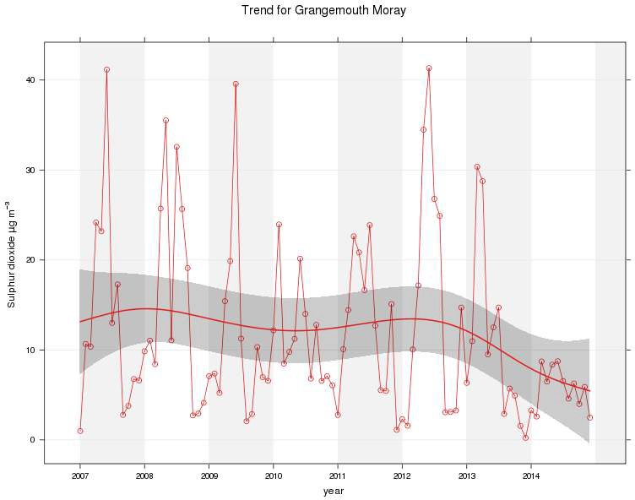
b.) Monthly concentrations at the Grangemouth Moray site between 2007 and 2014.

Figure 2.7 Polar Plots of SO₂ Concentrations in the Grangemouth AQMA in 2014.
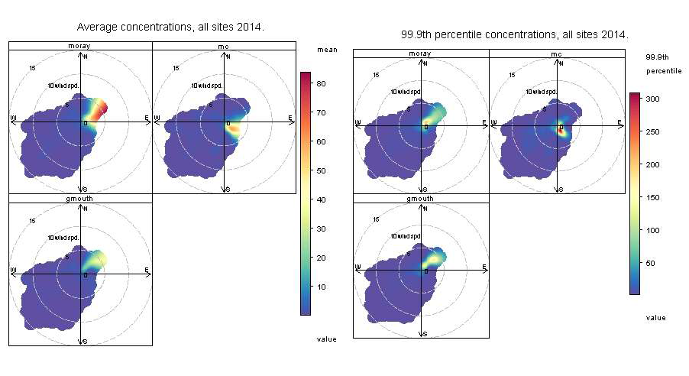

Figure 2.8 Polar Plots of SO₂ Concentrations in the Grangemouth AQMA in 2012.
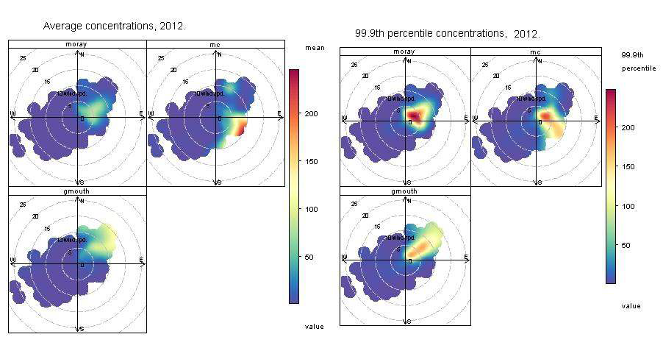

Benzene

In 2014 Falkirk Council monitored benzene at 16 locations using passive diffusion tubes. In addition, at the Grangemouth AURN (A8) site a pump diffusion tube operates as part of the AURN network. The results from the pump diffusion tube are shown in Table 2.10 with the passive diffusion tube results in Table 2.11.

All the benzene concentrations recorded by the tubes were within the air quality objectives. All benzene diffusion tubes achieved data capture greater then 75%. A pumped diffusion tube is generally considered to be more accurate than a passive diffusion tube. In 2014 the pumped diffusion tube at the Grangemouth AURN site recorded an annual average concentration of 0.99 Gg/m³. Please note that October to December 2014 data has not been finalised. The concentration recorded continues to be within the relevant objectives and is a decrease compared to 2013. It is also the lowest annual concentration recorded since monitoring began in 2002.

Table 2.10 Results of pumped benzene diffusion tube.

Site | Location | Data capture, | Annual mean concentration, Bg/m³
Site | Location | 2014, %. | 2010 | 2011 | 2012 | 2013 | 2014
A8 | Grangemouth AURN | 100 | 1.42 | 1.26 | 1.97 | 1.13 | 0.99

Table 2.11 Results of passive benzene diffusion tubes.

Site | Location | Within benzene AQMA? | Data capture, 2014, %. | Annual mean concentration, Bg/m³
 |  |  |  | 2011 | 2012 | 2012 # | 2013 | 2014
NA3 | Tinto  Drive,Grangemouth | N | 100 | 1.22 | 1.23 | n/a | 1.39 | 1.30
NA21 | Grangemouth Road,  College | N | 75 | 0.92 | 1.91 | 1.73 | 1.25 | 1.13
NA27 | West Bridge Street,  Falkirk | N | 83 | 1.49 | 2.09 | 1.78 | 1.52 | 2.39
NA37 | Denny Town House | N | 92 | 0.87 | 1.38 | n/a | 1.16 | 1.09
NA38 | Larbert Village Primary  School | N | 100 | 1.36 | 1.37 | 1.32 | 0.85 | 1.04
NA41 | Seaview Place, Bo'ness | N | 83 | 2.19 | 2.14 | 2.05 | 1.84 | 1.97
NA42 | Municipal Chambers,  Grangemouth | N | 75 | 0.91 | 1.62 | 1.41 | 1.59 | 1.25
NA44 | Greenpark Drive,  Polmont | N | 83 | 0.84 | 1.49 | 1.21 | 1.16 | 1.34
NA55 | Inchyra Station | N | 83 | 1.42 | 3.29 | 3.04 | 1.38 | 1.32
NA57 | Inchyra Road,  Grangemouth | N | 83 | 1.31 | 2.39 | n/a | 1.33 | 1.96
NA77 | Kinnaird Village | N | 92 | 0.63 | 1.32 | n/a | 1.12 | 1.04
NA80 | Cow Wynd, Falkirk | N | 92 | 1.11 | 1.75 | 1.52 | 1.53 | 1.33
NA81 | Grahams Road, Falkirk | N | 100 | 1.04 | 1.37 | n/a | 1.47 | 1.25
NA94 | A905 (Glensburgh Rd),  Grangemouth | N | 100 | 0.77 | 1.67 | n/a | 1.71 | 1.13
NA102 | East Kerse Mains, Bo'ness | N | 92 | 0.69 | 1.76 | n/a | 1.35 | 1.26
NA105 | West of Shieldhill | N | 92 | 0.91 | 1.26 | 1.1 | 0.69 | 0.74
Note: April 2014 results not covered by UKAS accreditation due to high QC results.

Falkirk Council has considered INEOS’ community monitoring results. In 2014 all the sites met the Scottish benzene objective. ^{Ref} ²

Other Pollutants Monitored

1,3 Butadiene
In 2014 Falkirk Council monitored 1,3 butadiene at three locations using passive diffusion tubes. All the results were within the objective and are shown in Table 2.12. All annual concentrations were within the objective. The annual concentrations have decreased since 2013. This is due to the detection limits reducing following a change in contractor (ESG to Gradko) supplying and analysing the tubes from April 2014.

Table 2.12 Results from 1,3 butadiene diffusion tubes.

Site ID | Location | Within 1,3 butadiene | Data capture in | Annual mean concentrations (Gg/m³)
Site ID | Location | AQMA? | 2014, %. | 2011 | 2012 | 2013 | 2014
NA41 | Seaview Place,  Bo’ness | N | 100 | 0.85 | 1.19 | 1.25 | 0.42
NA55 | Inchyra Station,  Grangemouth | N | 91.7 | 0.85 | 1.19 | 1.25 | 0.48
NA104 | Powdrake Road,  Grangemouth | N | 91.7 | 1.16 | 1.19 | 1.25 | 0.47

PM2.5
A Scottish Government owned PM_{2.5} FDMS%TEOM commenced operation at the Grangemouth AURN (A8) site in December 2008. The Scottish Government has announced that it wishes local authorities to review and assess PM_{2.5}. This is in addition to PM₁₀ and will result in a PM_{2.5} objective being placed into legislation. Therefore in%line with previous reports the PM_{2.5} results from the Grangemouth AURN (A8) site are included but considered in slightly more detail.

The Grangemouth PM_{2.5} results are shown in Table 2.13. The concentration recorded in 2014 at the Grangemouth AURN (A8) site was 8.0 Gg/m³. This concentration is below the Scottish Government’s interim target value of 12 Gg/m³. It is also lower than the World Health Organisation standard, which the Scottish Government has proposed to adopt, of 10 Gg/m³. In 2014 the annual concentration recorded was the lowest since monitoring began in December 2008. The PM_{2.5} concentrations in Grangemouth has gradually reduced from 10.9 Gg/m³ in 2011 to 8.0 Gg/m³ in 2014. However, as shown in Figure 2.9 this follows a slow increase in concentrations between 2008 and 2011.

In addition, PM_{2.5} monitoring commenced in Banknock in February 2015 with the installation of a FIDAS 200. The measurement of PM_{2.5} at this monitoring site is primarily focused on assisting with source identification in the area. However, if a 10 Gg/m³ objective is placed into

legislation the unit will serve a secondary purpose and naturally the data will be compared against the objective.

Table 2.13 Results from PM_{2.5} monitoring.

Site ID | Location | Data Capture in 2014, % | Annual mean concentration (Bg/m³)
Site ID | Location | Data Capture in 2014, % | 2011 | 2012 | 2013 | 2014
A8 | Grangemouth AURN | 92.4 | 10.9 | 10.5 | 9.2 | 8.0

Figure 2.9 a.) Deseasonalised and b.) absolute PM_{2.5} concentrations at Grangemouth between December 2008 and December 2014.
a.)
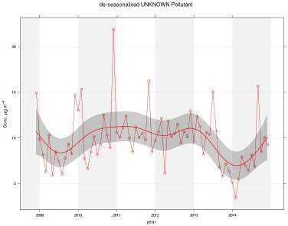

b.)
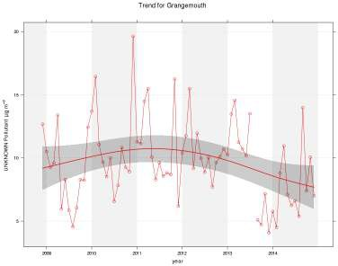

Summary of Compliance with AQS Objectives

Falkirk Council has examined its 2014 automatic and non%automatic monitoring results. The Falkirk West Bridge St automatic monitoring site and the diffusion tube on the same street breached the annual NO₂ objective. No other diffusion tubes breached the annual NO₂ objective. No monitoring sites breached the annual or daily PM₁₀ objectives.

The six SO₂ automatic monitors met all three (15%minute, hourly and daily) objectives. However, the number of exceedances at the Grangemouth MC site was close to the 15% minute objective with 30 exceedances. There were no exceedances of the hourly or daily limit value.

The benzene and 1,3 butadiene diffusion tube monitoring conducted in 2014 met the objectives.

The PM_{2.5} monitor at the Grangemouth AURN site recorded a concentration of 8 Gg/m³. This level is within the Scottish Government’s interim target value of 12 Gg/m³ and the proposed
10 Gg/m³ objective. PM_{2.5} monitoring commenced monitoring at the Banknock 2 site in February 2015 to primarily assist with source identification.

No carbon monoxide or lead monitoring is conducted in the Falkirk Council area.

There are no outstanding changes to the automatic monitoring network.

Road Traffic Sources
This section and sections 4 to 7 will review any changes in the Falkirk Council area that may affect air quality, for example new transport sources, industrial emissions or new receptors. It will focus on locations which have not been assessed during the earlier rounds, or where there has been a change to an existing installation or a new development.

This section will review any changes to the following since the 2014 Progress Report:
- Narrow congested streets with residential properties close to the kerb,
- Busy streets where people may spend one hour or more in proximity to traffic,
- Roads with a high flow of buses and / or HGVs,
- Junctions,
- New roads constructed or proposed since the last Review and Assessment report,
- Roads with significantly changed traffic flows,
- Bus or coach stations.

The main pollutants that Local Authorities are required to assess from road traffic are NO₂ and PM₁₀. Emissions of benzene, 1,3 butadiene and carbon monoxide from road traffic are now insignificant.

Figure 3.1 shows that the total amount of road traffic, by vehicle miles with 2000 as a base year, on Falkirk Council’s roads reached an initial peak in 2007 and then declined through to 2010. An increase through to 2012 was experienced which then levelled off in 2013 and 2014. Using the year 2000 as a base year of 100, 2007 was equal to 117 with 2014 equal to 121.

Figure 3.1 All motor vehicles traffic on major roads in Falkirk Council area, 2000 to 2014
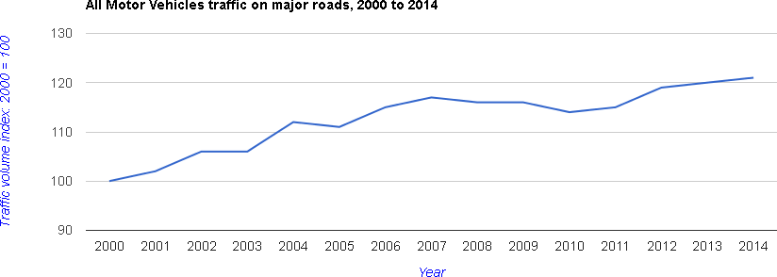
Reference 3

Narrow Congested Streets with Residential Properties Close to the Kerb
The technical guidance states that a Detailed Assessment should be made of any narrow congested streets identified where there is relevant exposure. Narrow congested streets are typically those where the AADT is greater than 5,000 with congestion occurring throughout the day (slow moving traffic with frequent stopping and starting throughout much of the day, traffic speed 25 kph or less) and with residential properties within 2 m of the kerb.

There are no new locations that are likely to be congested residential streets that have not been considered before or are not already in AQMAs.
Falkirk Council confirms that there are no new or newly identified congested streets, with a flow above 5,000 vehicles per day and residential properties close to the kerb, that have not been adequately considered in previous rounds of Review and Assessment.

Busy Streets Where People May Spend 1-hour or More in proximity to Traffic
The technical guidance states that a DMRB screening assessment should be undertaken for any road with an AADT greater than 10,000 vehicles per day where people may spend 1% hour or more in proximity to traffic (within 5 m of the road). Examples are likely to include town and city centres where shops are located near busy roads.

In addition, the automatic monitoring network recorded no exceedances of the hourly objective concentration and all of the diffusion tubes recorded concentrations below 60 Gg/m³.

Falkirk Council is not aware of any links where there are any new locations where people may spend 1%hour or more in proximity to traffic.
Falkirk Council confirms that there are no new or newly identified busy streets where people may spend 1%hour or more in proximity to traffic.

Roads with a High Flow of Buses and / or HGVs.
The technical guidance specifies that a DMRB assessment should be undertaken for roads where the proportion of HDVs is greater than 20% of the traffic flow with a HDV flow of greater than 2,500 vehicles per day and where there is relevant exposure within 10 m of the road (20 m for conurbations greater than 2 million).

There are no stretches of roads in the Falkirk Council area where the percentage of HDVs is greater than 20%. Therefore no further consideration is required.

Falkirk Council confirms that there are no new roads with high flows of HDVs.

Junctions and busy roads in Scotland
The technical guidance states that a DMRB screening assessment should be undertaken for roads and / or junctions (that have not been assessed before) where the AADT is greater than 10,000 vehicles per day and where there is relevant exposure within 10 m (20 m for conurbations greater than two million people). In addition, due to the tighter Scottish PM₁₀ objective a DMRB run is required where either the background concentration of PM₁₀ is greater than 15 Gg/m³ and the AADT greater than 5,000 or where a 10% increase in flow has been recorded. Thus the focus is on links that have experienced a 10% increase in flow with an AADT of 5,000 or greater.

The following links have been considered with a DMRB run with results shown in Table 3.1:

% | A803 Glenfuir Road to Rosebank roundabout.
% | A803 Bridge St to the Bypass Road Dennyloanhead.
% | B9132 Abbots Road between Newhouse Road to Bo’ness Road.

Table 3.1 Results of the DMRB runs.

Road | NO₂ annual  mean, Bg/m³ | PM₁₀ annual  mean, Bg/m³
A803 Glenfuir road to Rosebank  roundabout | 28.8 | 16.9
A803 Bridge St to the Bypass  Road Dennyloanhead | 28.4 | 16.3
B9132 Abbots Road, Newhouse Road to Bo'ness Rd | 25.6 | 14.5

The following diffusion tube shall be relocated:
% Inchyra Road (NA57): the relevant receptor is slightly greater than 10 m from the kerb. However, diffusion tube (NA57) shall be re%located so that it represents these receptors on the southern section of the road close to junction 5 of the M9.

Transport Planning have reported that there are increased levels of congestion at the junction of the M876 and M80. This follows the M80 upgrade and the reduction of the speed limit on the A803 to 30 mph. There are no receptors within 50 m of the kerb and thus it need not be considered any further.
Falkirk Council confirms that there are no newly identified busy junctions or roads that require a Detailed Assessment. However, the list of DMRB runs is used to guide future changes to the diffusion tube network.

New Roads Constructed or Proposed Since the Last Round of Review and Assessment
This section reviews newly constructed or upgraded roads in the Falkirk Council area.

The slip%road at junction 6 from the M9 onto Glensburgh Road in Grangemouth has been re% designed and signalised. In addition, the subsequent roundabout has been signalised. In Figure 3.2 two photos show the previous and new layout. The construction works were completed in April 2014.

The new layout has moved traffic away from the diffusion tube NA94 on Glensburgh Road (and hence the nearby receptor). This is because the vast majority of the traffic travels straight through the junction in the new second and third lanes. The new layout then allows left%turning traffic to be served by a dedicated near%side lane that is subject to reduced congestion.

In 2013 the annual mean NO₂ concentration at diffusion tube NA94 was 36 Gg/m³ and in 2014 the concentration reduced to 31 Gg/m³. The diffusion tube monitoring will continue at the site. However, the results indicate that there has been a reduction in concentrations of NO₂ in the vicinity of this site. It is likely that the re%designed junction has contributed to a reduction in NO₂ concentrations in the area. This is because the distance between the tube (and thus receptor) and dominant emissions source (road traffic) has increased and congestion has reduced.

Figure 3.2 Photos of a.) the old and b.) new road layout along Glensburgh Road, Grangemouth.
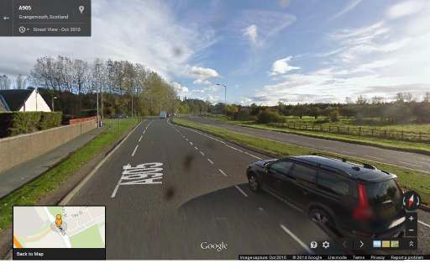
- Old road layout.

- New road layout.
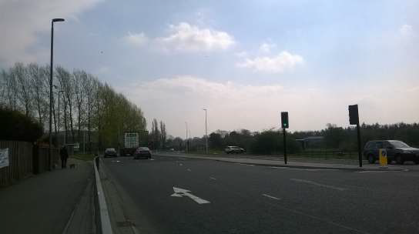
Falkirk Council has assessed the major new roads meeting the criteria in Section A.5 of Box
5.3 in TG(09). The diffusion tube monitoring at site NA94 will continue but concentrations have decreased noticeably between 2013 and 2014 following the junction re%design.

Roads with Significantly Changed Traffic Flows
For Scottish authorities the guidance relating to Section 3.4 requires assessment of roads where traffic levels have increased by 10% or more for PM₁₀. The guidance in this section requires an increase of 25% but includes NO₂. The DMRB runs conducted in Section 3.4, where the requirement was for a link to have a 10% increase, included NO₂ and so does not need to be considered again.
Please see conclusion of Section 3.4.

Bus and Coach Stations
There are no new or significantly changed bus or coach stations within the Falkirk Council area.

However, nine new Euro V hybrid buses commenced operation in the Falkirk Council area in November 2014. The First Group buses are running on their number 3 and 4 routes which operate between the Falkirk wheel and Grangemouth and a photograph is shown in Figure
3.3. The routes include Falkirk Town Centre and specifically West Bridge Street. The hybrid element of the vehicles powers the electrical requirements of the bus. This reduces the load on the engine and is a contrast to other hybrids where the electrical power is used to fully or partly drive the vehicle.

Figure 3.3 A photograph of First Group’s hybrid bus during its launch.
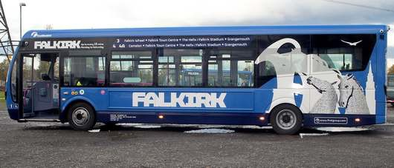
Reference 4

Subsequently First Group has announced another order of 385 new vehicles across its UK operations. It is understood that 26 of the new vehicles (Figure 3.4) will operate in the Falkirk area along with a further 15 ‘nearly new’ vehicles that are cascaded from other operations. All the new vehicles supplied to Scotland will be Euro VI. Once the vehicles are operating further details will be provided in next year’s air quality report.

Figure 3.4 The photograph accompanying First Group’s announcement of their new vehicle order.


Reference 5.

Falkirk Council confirms that there are no changes to any bus or coach stations in the area.

Other Transport Sources
This section considers the potential emissions to air from other types of transport. This includes airports, diesel and steam trains, both stationary and moving, and movements of ships to and from ports.

Airports

The number of airport passenger movements at Edinburgh between 2013 and 2014 has increased by 3.8% from 9.775 million to 10.159 million. ^{Ref} ⁶ The airport does not need considering further as it is greater than 1 km from the Falkirk Council boundary.

Falkirk Council is not aware of any significant changes to Cumbernauld airport. This is a small airport just outside the Falkirk Council area boundary. There are no new airports either.
Falkirk Council confirms that there are no airports in the Local Authority area and none nearby that require a Detailed Assessment.

Railways (Diesel and Steam Trains)

Falkirk Council has previously assessed emissions from diesel and steam locomotives. Six rail lines are operational in or near to the Falkirk Council area:

- The main Edinburgh to Glasgow line passes east to west with stations at Polmont and Falkirk High,
- A line connecting Glasgow with Stirling passing southwest to northeast through the Council area with a station at Larbert,
- A route linking Edinburgh and Stirling passing southeast to northwest through the Falkirk Council area with stations at Falkirk Grahamston, Camelon and Larbert,
- A freight line linking Grangemouth Docks and industrial complex to the mainline in the east of Falkirk,
- A part%time heritage passenger route that operates steam and diesel locomotives between a junction east of Linlithgow on the main Edinburgh to Glasgow line and Bo’ness with stations at Birkhill, Kinneil and Bo’ness,
- A re%built electrified line between Airdrie and Bathgate, 1.3 km south of the Falkirk Council boundary.

Stationary Trains

Falkirk Council is not aware of any new locations where locomotives or trains are stationary for more than 15%minutes that would not have been assessed in previous reports.
Falkirk Council confirms that there are no locations where diesel or steam trains are regularly

stationary for periods of 15 minutes or more, with potential for relevant exposure within 15 m.

Moving trains

Line one of the rail lines listed in Section 4.2 is the busiest in the Falkirk Council area. The 2009 U&SA report did not require assessment of this line, although as a precaution a NO₂ tube was placed close to Falkirk High station. The site recorded a concentration of 22 Gg/m³ in 2010. This is within the NO₂ objective and so the site was discontinued.

As a result of the Edinburgh to Glasgow Improvement Programme (EGIP) line 1 will be electrified by 2016 and lines 2 and 3 by 2018. The current construction and delivery timetable
is:
% | 2012 to 2014: Extensive bridge clearance works.
% | May 2014: Electrification of Cumbernauld to Glasgow line.
% | June 2014: Completion of re%developed Haymarket Station.
% | July 2014: Opening of new station building at Cumbernauld.
% | May 2015: Completion of Haymarket to Inverkeithing signalling renewal.
% | April 2016: Last of 61 bridge clearance projects complete.
% | October 2016: Completion of intermediate station platform extensions (including
 | Falkirk High, Polmont and Linlithgow.)
% | December 2016: Completion of Edinburgh Waverley platform extensions.
% | December 2016: Introduction of first Edinburgh to Glasgow electric services.
% | December 2016: Completion of Edinburgh Gateway railway station.
% | December 2017: All electric fleet operating on Edinburgh to Glasgow services.
% | December 2018: Introduction of electric services on Stirling / Alloa / Dunblane
 | lines (this includes services through Falkirk Grahamston).
% | December 2018: Introduction of 8 car services and 42 minute journey time
 | between Edinburgh and Glasgow.

Lines two and three have fewer trains running than line one and Falkirk Council is not aware of any significant changes in the level of use. In addition, a NO_{x} analyser previously operated at the Falkirk Grahams Road site (A12). Although this was primarily located for road traffic emissions it was also adjacent to the Falkirk Grahamston railway station and was 6 m from the track side of line three. The line was also included in the Falkirk Town Centre Further Assessment. In addition, again primarily for road traffic emissions, a PM₁₀ monitor began operation at this location in December 2011 and met the objectives in 2014.

Line four runs through a mostly industrial area and has no new receptors. The Bo’ness and Kinneil steam railway (line five) continues to operate four departures and arrivals in each direction during its peak timetable. This timetable only operates on July and August weekends. This line was re%assessed in the 2013 Progress Report. ^{Ref} ⁷ Line six is electric and was discussed in the 2011 Progress Report.

It is concluded that these movements do not need to be considered further.

Falkirk Council confirms that there are no locations with a large number of movements of diesel locomotives, and potential long%term relevant exposure within 30 m.

Ports (Shipping)

In 2013, 1,202 ships called at the docks, and in 2014 1,196 ships called at the docks. ^{Ref} ⁸

The number of ships calling into Grangemouth has decreased and thus the docks do not need to be considered further. In addition, the docks are within the SO₂ Grangemouth AQMA and were considered in the original Further Assessment report. The Grangemouth MC (A10) monitoring site (with SO₂ analyser) is close to the docks and in 2014 this site met all three SO₂ objectives. In addition, the polar roses drawn have shown that the highest average concentrations do not occur when the wind direction originates from the direction of the docks.
Falkirk Council confirms that there are no ports or shipping that require further consideration.

Industrial Sources

Industrial Installations
This section considers the potential emissions from the following sources:
- Industrial installations: new or proposed installations for which an air quality assessment has been carried out,
- Industrial installations: existing installations where emissions have increased substantially or new relevant exposure has been introduced,
- Industrial installations: new or significantly changed installations with no previous air quality assessment,
- Major fuel storage depots storing petrol, petrol stations and poultry farms.

New or Proposed Installations for which an Air Quality Assessment has been carried out
The information supplied by SEPA stated that there were no new installations.
Falkirk Council confirms that there are no new or proposed industrial installations for which planning approval has been granted within its area or nearby in a neighbouring authority.

Existing installations where emissions have increased substantially or new relevant exposure has been introduced.
The information supplied by SEPA stated that there were no existing installations where emissions have increased substantially.

PPC/E/0020072, Sulzer Dowding & Mills Engineering, Larbert. This site has mothballed their process and is applying to surrender as they do not intend to operate in the future. The site had permit emission conditions relating to emissions of NO_{x}.
Falkirk Council confirms that there are no industrial installations with substantially increased emissions or new relevant exposure in their vicinity within its area or nearby in a neighbouring authority.

New or Significantly Changed Installations with No Previous Air Quality Assessment
The information supplied by SEPA stated that there were no new installations.
Falkirk Council confirms that there are no new or proposed industrial installations for which planning approval has been granted within its area or nearby in a neighbouring authority.

Major Fuel (Petrol) Storage Depots
There are major fuel (petrol) storage depots within Falkirk Council area but these have been considered in previous reports. In addition, benzene monitoring is currently carried out in Grangemouth and other parts of the Falkirk Council area. As shown in Tables 2.10 and 2.11 there were no breaches of the benzene objectives in 2014.
There are major fuel (petrol) storage depots within the Falkirk Council area but these have been considered in previous reports. Benzene monitoring is conducted in the Falkirk Council area and the results indicate no exceedances of the Scottish or UK / EU objectives.

Petrol Stations
The technical guidance states that there is potential to exceed the 2010 annual mean benzene objective where there is relevant exposure within 10 m of the pumps of a petrol station with an annual throughput of greater than 2000 m³ which is located close to a road with a traffic flow greater than 30,000 AADT.

The information supplied by SEPA stated that there were no new installations.
Falkirk Council confirms that there are no petrol stations within its area meeting the specified criteria that require assessment.

Poultry Farms
The information supplied by SEPA did not state that there were any changes to poultry farms or new installations.
Falkirk Council confirms that there are no poultry farms within its area meeting the specified criteria that require assessment.

Additional information about industrial emissions in the Falkirk Council area
It was announced by INEOS in March 2014 that the ethylene cracker (G4) and butadiene plant (BE3) have closed. http://www.ineos.com/news/ineos%group/grangemouth%milestones/?business=INEOS+Group

As widely report in the media (http://www.bbc.co.uk/news/uk%scotland%edinburgh%east%fife% 33970594) it has been announced by Scottish Power that Longannet Power Station will close in March 2016. This will be considered by any future assessments of sulphur dioxide in the Grangemouth AQMA and the impact, if any, will be accounted for by the Grangemouth AQMA SO₂ monitors.

In February 2015 the Scottish Government announced a moratorium on granting consents for unconventional oil and gas developments in Scotland. The moratorium is to continue until work including a full public health assessment and a review current planning and environmental guidance is conducted. The reporters of an application in the Falkirk area (PPA%240%2032 (Planning Permission Appeal), Land located 230 m south of Powdrake farmhouse, Powdrake Road, near Airth, Plean and Letham Moss, Falkirk) have therefore suspended their work on this appeal. In respect of this application it is noted that Defra have proposed that benzene will be removed as part of Local Air Quality Management in England. The Scottish Government has yet to announce the pollutant details of any revised LAQM process in Scotland.

Commercial and Domestic Sources
This section considers the potential emissions from the following sources:
- Biomass combustion plant, individual installations,
- Areas where the combined impact of several biomass combustion sources may be relevant,
- Areas where domestic solid fuel burning may be relevant.

Biomass Combustion – Individual Installations
There are no new individual biomass combustion individual installations that require consideration.
Falkirk Council confirms that there are no new biomass combustion plant in the area that have been granted planning permission.

Biomass Combustion – Combined Impacts
Falkirk Council has assessed domestic biomass or other fuel burning in previous reports. Falkirk Council has either received no significant numbers of complaints about particular areas in relation to or changes to the following:

- Complaints about nuisance dust or odour relating to burning,
- Visual signs of chimney smoke being emitted from several properties near to each other,
- Smell of burning biomass fuel,
- Known high levels of sales of biomass or other fuels via home delivery or local outlets,
- Areas known to have limited or no access to mains gas.
Falkirk Council confirms that there are no biomass combustion plant in its area that require a Detailed Assessment.

Domestic Solid-Fuel Burning
Falkirk Council has assessed domestic solid fuel burning in previous reports and is not aware of any new areas that would need consideration.

A map of the smoke control areas in the Falkirk Council area is available to view on the Falkirk Council website at www.falkirk.gov.uk/airquality and is shown in Figure 6.1.

Figure 6.1 A map of the merged smoke control areas in the Falkirk Council area.
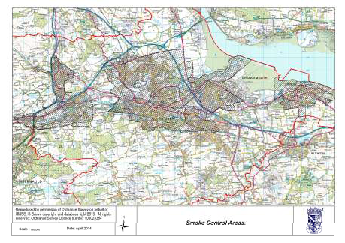

There may be improvements to emissions for this section. In areas where there is no mains gas, a change from coal or wood burning on open fires to using wood burning stoves has the potential to reduce emissions.
Falkirk Council confirms that there are no areas of significant domestic fuel use in its area.

Fugitive or Uncontrolled Sources
This section considers the potential emissions from the following sources:
- Landfill sites,
- Quarries,
- Unmade haulage roads on industrial sites,
- Waste transfer stations,
- Other potential sources of fugitive particulate emissions.

Landfill sites are regulated by SEPA and no changes with respect to the pollutants covered by this report have been indicated by SEPA.

The new quarry in the vicinity of the Banknock AQMA is discussed in Section 8.

Falkirk Council is not aware of any other changes to unmade haulage roads on industrial sites, waste transfer stations or other potential sources of fugitive particulate emissions.
Falkirk Council confirms that there are no new potential sources of fugitive particulate matter emissions in its area.

AQMA, Action Plan and Other Strategy or Policy Updates
Grangemouth AQMA (SO₂ 15-minute) AQMA and Action Plan
In 2014 Falkirk Council monitored sulphur dioxide at six locations and the results were shown in Table 2.9. The three sites in the AQMA (Grangemouth AURN, Moray and Municipal Chambers) met the 15%minute objective. In addition, the daily and hourly objectives were met. The monitoring sites outside the AQMA met all three objectives.

The 2014 monitoring results are reasonably consistent with the 2013 monitoring results. No breach of the 15%minute objective was recorded in 2013 and 2014. All monitoring sites achieved 90% data capture. However, there were 25 exceedances recorded at Moray in 2013 and 30 exceedances recorded at Municipal Chambers in 2014. Thus it can be considered that the number of 15%minute exceedances remains close to the objective. There have been no 15%minute exceedances recorded at a monitoring site outside the AQMA since August 2012.

A smooth trend plot of concentrations and polar roses were shown in Figures 2.6 to 2.8. These graphs and the number of recorded exceedances show a reduction in sulphur dioxide levels and an improvement in air quality in the AQMA since the commissioning of the Tail Gas Unit in August 2013.

The original AQMA declaration related to a potential breach of the 15%minute objective. However, between 2007 and 2012 a breach of the objective was recorded. It is thus considered that this AQMA has changed from being a clear breach of the objective (between 2007 and 2012) to its original declaration, that is, there is potential for the objective to be breached. It is considered that the Grangemouth AQMA remains justified because the number of exceedances, in 2014 particularly, was close to the objective. However, the strength of this justification has significantly weakened since the commissioning of the Tail Gas Unit.

The Grangemouth Zetland Park has been positioned to support any AQMA amendment or revocation. The Grangemouth AQMA Action Plan included four measures and an update of these is provided in this section.

Measure 1:
Eight of Falkirk Council’s automatic monitoring stations are affiliated to either the AURN or the Scottish Air Quality Network with the data displayed on the appropriate website. This includes five of the six SO₂ analysers that are used for monitoring in relation to the Grangemouth AQMA. The data from the Bo’ness site is available on request.

Falkirk Council sends meteorological data and provisional SO₂ to SEPA, INEOS and Petroineos when an SO₂ exceedance is recorded at a monitoring station. In addition, a

monthly summary is sent. The monthly summary includes data for each site, a list of the exceedances and as necessary polar roses or other analysis.

Measure 2:
As discussed in the 2014 Progress Report a working group meeting was held in November 2013 as it was post%commissioning of the Tail Gas Treatment unit.

It was agreed by the working group that another meeting would only occur if there was another breach of the sulphur dioxide objectives.

Measure 3:
Falkirk Council’s text alert system has been implemented and is being maintained. The Scottish Air Quality Network has recently launched an air quality alert system for the public (http://www.scottishairquality.co.uk/know%and%respond/). Falkirk Council will continue to run its system as it is pollutant and site specific.

Measure 4:
The monitoring site changes that have been implemented since the declaration of the AQMA are:
- The Grangemouth Moray site commenced operation in September 2006 with the SO₂ analyser. This analyser and site continues to operate.
- The Abbotsford House site ceased operation on the 16th April 2010. The unit was relocated to Polmont and commenced operation in September 2010 and ceased operation at in September 2012. During this period there was only one 15%minute exceedance recorded during the period of monitoring.
- Following the commissioning of the Tail Gas Unit in August 2013 the justification and viability of operating two SO₂ analysers in Falkirk was considered. The 15%minute objective continues to be met outside the Grangemouth AQMA. With few exceedances recorded outside the Grangemouth AQMA and zero since August 2012 it was considered that one of the Falkirk SO2 sites should cease operation. The Falkirk Hope St site has been in operation longer than Falkirk Park St and is a fixed site. The Falkirk Park is a mobile unit and a re%location was to benefit the Falkirk Townscape Heritage Initiative. It was considered that Falkirk Park St was no longer required for either the road traffic or Grangemouth AQMA work. Therefore the Falkirk Park St site ceased operation in April 2014.
- The Falkirk Park St enclosure was re%located to Zetland Park in Grangemouth. The SO₂ analyser was commissioned in May 2015. The NO_{x} and PM₁₀ analysers have been utilised at the new Main Street, Bainsford, monitoring site.
- Falkirk Council is observing developments of small SO2 ‘sensors’. It is unlikely that these will replace the reference monitoring that is conducted at the automatic sites. However, they may be useful in providing indicative measurements in additional areas and may aid location of any future monitoring sites.
- It is likely that by March 2016 the Grangemouth Moray and Bo’ness SO₂ analysers, which are more than 15 years old, will be replaced because spare parts will no longer

be manufactured. The replacement will thus ensure that monitoring can continue into the future. It is anticipated that other analysers will be replaced in due course. The exception is the Grangemouth AURN analyser which was replaced in 2012 as part of a Defra funded AURN replacement programme.

Table 8.1 Update on Grangemouth AQMA Action Plan measures

Measure Number | Measure | Focus | Lead authority | Progress to date | Progress in last 12 months | Estimated completion date | Comments relating to emission  reductions
1 | Improving data access | Supplying monitoring data to SEPA, Petroineos and INEOS. | Falkirk Council | Data sent after exceedances, monthly summary sent. | Same as Progress to date. | Ongoing. | See comments in this Section.
2 | Working group. | Bring together FVHB, Petroineos, INEOS, S.Govt,  SEPA and Falkirk  Council. | Falkirk Council | TGU full commissioned in August 2013, meeting held in November 2013. | Same as Progress to date. | Completed. Meeting only if breach of objective  occurs. | Objectives met in 2013 and  2014.
3 | Text alert system. | Real%time notification of exceedances. | Falkirk Council | Implemented. | Maintenance of system.  Considering upgrade of comms  to GPRS. | Completed and ongoing. Grangemouth AURN sends  e%mails. | n/a
4 | Monitoring network. | Review monitoring network. | Falkirk Council | Grangemouth Moray SO₂ in SAQN.  Monitoring conducted in Polmont and Grangemouth Zetland Park. | Falkirk Park St ceased operation April 2014. Zetland Park to commence April 2015.  Observing  development of SO2 ‘sensors’. | Ongoing | See comments in this and Section 2.

Falkirk Town Centre (NO₂ hourly and annual) AQMA
The draft Falkirk Town Centre and Haggs air quality Action Plan was submitted in August 2014 to the Scottish Government and SEPA. The final copy of the Action Plan has now been submitted and accepted.

Table 8.2 provides a general update on the air quality Action Plan measures which further detail on some of the measures described in this section.

Measure 3: Falkirk Council has produced an Eco driving leaflet which is available to view on Falkirk Council’s website: http://www.falkirk.gov.uk/services/roads%parking% transport/transport/docs/car%pooling/Guide%20to%20Eco%Driving.pdf?v=201406020913
This includes a paragraph relating to diesel vehicles and air quality:
“Diesel cars emit less CO2 than their petrol equivalents, but produce more ‘air quality’ emissions, such as nitrogen oxides (NOx) and particulates, which towns and cities and affect our health. If you considering buying a diesel car, choose one with a diesel particulate filter to reduce particulate matter emissions”.

Measure 5: The possibility of including ECO Stars in the assessment of tendered bus service contracts has been discussed with the Public Transport Co%ordinator. In addition, it is likely that operators will be invited to provide bids in relation to the provision of newer buses. However, the use of new vehicles will need to be balanced against the additional cost incurred (mostly due to reduction in fixed capital). The tendered network is currently under a review and new contracts will be considered during 2016.

Measure 6: The improvements to the three set of traffic lights along the Main Street, Bainsford and Grahams Road route into Falkirk have been completed and one of lights is shown in Figure 8.1

Figure 8.1 Picture of traffic lights at the Main St, Bainsford and Bankside junction.
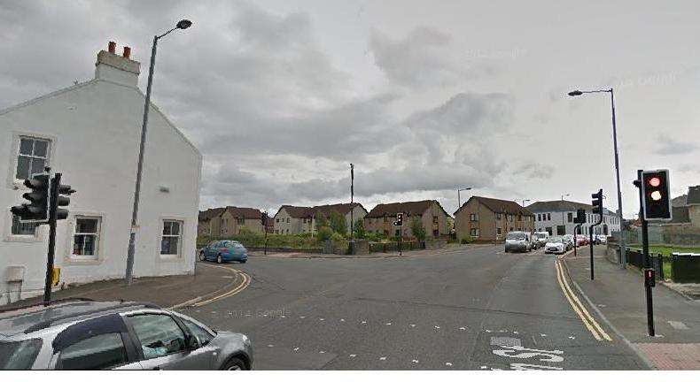

Measure 14: In June 2015 Falkirk Council adopted its Local Development Plan which includes a policy on Air Quality. RW07 states:

“The Council will seek to contribute to the improvement of air quality. Impacts on air quality will be taken into account in assessing development proposals, particularly within Air Quality Management Areas (AQMAs). An Air Quality Assessment may be required for developments that are within AQMAs or where the proposed development may cause or significantly contribute towards a breach of National Air Quality Standards. Development proposals that result in either a breach of National Air Quality Standards or a significant increase in concentrations within an existing AQMA will not be permitted unless there are over%riding issues of national or local importance.”

Measure 15: Falkirk Council continues to monitor NO_{x} and PM₁₀ in its AQMAs. As described in Section 2 the Falkirk West Bridge St NO_{x} analyser and enclosure were replaced in January 2015. The Hope St site continues to monitor NO_{x}, the Grahams Road site PM₁₀ and the Haggs site measures NO_{x} and PM₁₀.

Measure 16: In February 2013 the Falkirk ECO Stars scheme was launched at the Falkirk Stadium (www.falkirk.gov.uk/ecostars). ECO Stars is an environmental fleet management recognition scheme for vans, lorries, buses and coaches. The scheme assesses individual vehicles and overall fleet operations to recognise levels of environmental performance. It provides advice and guidance on how to improve fuel efficiency and reduce operating costs. It also aims to raise awareness among operators of commercial vehicles of the important role they can play in helping to improve local air quality (particularly in the Council’s Air Quality Management Areas) and other environmental issues by enhancing their fleet performance. The scheme is voluntary and free to join and open to operators of buses, coaches, vans and trucks. In the UK the ECO Stars scheme also operates in six other Scottish local authority

areas and in South Yorkshire, Thurrock, Nottinghamshire, Mid%Devon and York. The Falkirk scheme has 71 members who operate 3,743 vehicles that are either based in or operate through the Falkirk Council area.

In November 2014 an extension of the ECO Stars scheme to permit taxis and private hire cars was approved. The recruitment of members is underway and a launch event expected in late 2015.

Measure 18: In May 2013 Falkirk Council agreed to the following Licensing changes to taxis and private hire car requirements: “that the current policy on the age of vehicles is changed to reduce the age at which a vehicle can first enter the fleet from 6 years to 3 years but that this is done progressively by a reduction of 1 year each year starting on 1 April 2014 and that the current policy requiring that each new operator licence is in respect of a wheelchair accessible vehicle be modified to the requirement being for a wheelchair accessible vehicle or for a hybrid or electric vehicle;”

“that a training requirement is introduced in regard to drivers standards for new taxi and private hire drivers only (with the option for the Civic Licensing Committee to attach the condition in other cases where it considers it necessary) and that officers are instructed to bring proposals on the content of the training requirement following discussion with training providers to a future Committee;”.

This has been followed by the extension of the ECO Stars scheme to permit taxis and private hire vehicles to become members of the scheme. These two actions therefore achieve a balance between legislative requirements and voluntary actions by operators to reduce their emissions.

Measure 19: Falkirk Council is part of a vehicle emissions partnership that aims to educate drivers' with the aim of reducing harmful vehicle emissions.

Smoke and fumes that come from vehicle exhausts are harmful to health. To report 'smoky' or idling vehicles contact the hotline number 01845 451888 or text 'idle' to 60777, and leave the following details:
- Location
- Registration number
- Owner details (if known)
- Date and time
- And for idling, how long the vehicle remained stationary with its engine running.

The aim of vehicle emission testing is to emphasise the importance of well%maintained, clean and efficient vehicles which are cheaper to run, and will emit less pollution.

As well as carrying out the tests, the testing team can give practical advice on how to improve vehicle efficiency and reduce harmful emissions while saving on running costs. Anyone can come along and get their vehicles checked free of charge.

The dates for the 2015 vehicle testing season at Central Retail Park, Falkirk are:
% March 24, 25, 26, 27, 28, 29
% April 21, 22, 23, 24
% May 19, 20, 21, 22
% June 16, 17, 18, 19
% July 28, 29, 30, 31
% August 01, 02, 25, 26, 27, 28
% September 22, 23, 24, 25
% October 20, 21, 22, 23.

Table 8.2 Update on Falkirk and Haggs Action Plan Measures

Measure  Number | Description | Focus | Lead  Authority | Progress | Completion  date | Comments
1 | Council vehicles, advance date of older vehicles | Vans | Falkirk Council | 20% fleet will be replaced in 2014/15 and 2015/16. | Ongoing | Overall small number vehicles but large mileage in council area.
2 | Electric vehicles and plug%ins | Cars | Falkirk Council | Charging points at council depots and  points beginning to be installed in public places. | Ongoing
3 | Eco%advanced driver training | All types of vehicle, fuel use and emissions | Falkirk Council | Offered to Council services by fleet. | Ongoing
4 | Support local fuel stations to  provide alternative / green fuels chargers etc | All types of  vehicle and emissions | Falkirk Council | None | Unknown | Unknown
5 | Review of school bus contracts with view to raising  EURO standards | Buses | Falkirk Council | Discussions with Public Transport Co% ordinator about summer procurement  of services. | Ongoing | Buses only. Newer vehicles will require greater funding.
6 | Improvements of traffic lights  at Bankside | Congestion | Falkirk  Council | Completed | 2014
7 | Feasibility study of Haggs infrastructure changes | Congestion | Falkirk Council | Dependent on developer contributions and planning applications. | Dependent on developer contributions and planning  applications. | Unknown
8 | Feasibility study of West Bridge St and Town Centre traffic managemenr changes (speed limits, TROs etc) | Congestion | Falkirk Council | Dependent on planning applications. | 2017
9 | Take the Right Route | Car travel | Falkirk  Council | Scheme rolled out in Larbert and  Stenhousemuir. | Ongoing
10 | Council service based work  travel plan | Mode transfer | Falkirk  Council
11 | Introduce quality bus  corridors | Buses | Falkirk  Council | Future action. | n/a | Unknown
12 | Bike hire scheme | Mode transfer | Falkirk  Council | None | None | Unknown

Measure  Number | Description | Focus | Lead  Authority | Progress | Completion  date | Comments
13 | Soft measures e.g. travel  planning (larger employers, schools), journey sharing, changes to mileage, home and mobile working. | Variety | Falkirk Council | Tied in with Take the Right Route. | Tied in with Take the Right Route. | Ongoing
14 | Consideration of air quality in local development plan. | Development | Falkirk Council | Draft policy statement in plan. | Local Plan under  assessment. | 2015
15 | Appropriate air quality  monitoring in AQMAs. | n/a | Falkirk  Council | Monitoring maintained in AQMAs. | Ongoing | Increasingly subject to financial  pressures.
16 | Promotion of ECO Stars | Commercial vehicles, taxis and private hire cars. | Falkirk Council | Commercial vehicles scheme launched February 2013, extension to taxis and private hire cars commenced November 2014. Member workshop held in February 2015. | Ongoing | A voluntary scheme.
17 | Review of park and ride  facilties | Cars | Sestran | None | Unknown
18 | Taxi licensing | Taxis | Falkirk Council | Changes to licensing in May 2013 and Ecostars extended to taxis and private  hire cars. | Ongoing
19 | Vehicle emissions partnership (testing and idling) % enforcement and fines rather than raising  awareness. | Cars | Falkirk and other neighbouring authorities. | Falkirk central retail park testing schedule set for 2015. | Ongoing subject to annual funding allocation. | In partnership with the three Lothian authorities.
20 | Introduction of car clubs. | Cars | Developers | None | Unknown

Haggs (NO₂ annual) AQMA
This work is running in conjunction with the Falkirk Town Centre AQMA work.

In December 2013 PM₁₀ (TEOM) monitoring commenced at the Haggs (A4) monitoring site. In the Scottish Government’s low emission draft emissions strategy published in January 2015 it was stated that there will be a review of the particulate matter objectives. This will include PM₁₀ and PM_{2.5}. The proposal is to consider the adoption of the World Health Organisation standards with changes for PM₁₀ to 20 Gg/m³ and for PM_{2.5} to 10 Gg/m³. In 2014 the PM₁₀ monitoring results at the Haggs site monitoring met the current objective of 18 Gg/m³.

These two developments since the 2014 Progress Report have led Falkirk Council to conclude that the Haggs AQMA does not require amending to include PM₁₀. The existing monitoring will continue at the Haggs site. However, an adaption to PM_{2.5} is under consideration if the LAQM process is revised.

Banknock (PM₁₀ daily and annual) AQMA
This AQMA was declared in August 2011 for a breach of the Scottish objectives and a potential breach of the UK objectives.

In February 2015 the TEOM at the Falkirk Banknock / Banknock 2 monitoring site was replaced with a FIDAS 200 unit. This will enable PM₁₀ monitoring to continue into the future and has enabled the co%measurement of PM_{2.5}. The latter is primarily focused on future source identification rather than objective compliance. The Banknock 3 (Osiris) unit continues to operate at a background location which is 230 m from the A803 road.

The Banknock AQMA will remain in place at this time because the Tomfyne quarry has been given planning permission although it is subject to s75 and legal agreements before operations can commence. The revocation of the AQMA will be considered if the objectives continue to be met after the quarry is operating.

Local Transport Strategy
Falkirk Council has published its 2014 and onwards Local Transport Strategy. The key elements that relate to air quality are:

“Since the last LTS in 2006, there have been significant transport achievements in the Falkirk Council area. Just over £25 million has been spent on transport capital projects during this period that has enabled, among other things:
- Implemented A904 Grangemouth Road Crossing Facilities
- Implemented upgrading of Bo’ness Town Centre to benefit pedestrian environment
- Implemented Braes paths improvements resulting from community consultation
- Implemented Bo’ness / Blackness paths improvements from community consultation (excluding Blackness% Bo’ness shore route)
- Developed local networks suitable for walking around every settlement in the Falkirk Council area

- Bowtrees Roundabout to Bowtrees Cottage Cycle/ Footpath
- Provide Cycle Parking facilities at shopping centres, health and leisure centres
- First stage pilot project under auspices of Take the Right Route
- Improved multi user route access to Camelon and Larbert railway stations
- Produced Supplementary Planning Guidance for Developers to develop Travel Plans
- Operational car sharing database for Falkirk Council area
- Complete School Travel Assessments at all 56 Schools in Falkirk Council Area
- Install cycle parking and playground markings at 7 schools
- 20 mph signing installed at all schools
- Continuing development of the cycle network within and between settlements;
- Production and adoption of a Core Paths Plan;
- Ongoing work with local schools and employers to implement travel plan initiatives;
- Extension of Larbert Station car park
- Ongoing support of tendered bus services;
- Producing the detailed design of A801 Avon Gorge Improvement scheme;
- Ongoing maintenance of the Council’s road, footway, bridges and structures stock;
- Production of a Road Maintenance Plan;
- Ongoing detailed structural inspection of the street lighting stock;
- Completion of the A9 / Icehouse Brae Junction Improvement, Laurieston;
- Construction of Phase 1 of the Denny Eastern Access Road, and;
- Construction of the M876 Glenbervie Slip Roads junctions.

The two air quality policies in the Local Transport Strategy are:
“AQ1 The Council will continue to monitor and analyse air quality data throughout the Council area in compliance with the requirements of the Environment Act 1995 and subsequent regulations.

AQ2 The Council will work with partner agencies, to implement transport initiatives to assist in improving air quality and to work towards achieving the air quality objectives through the measures that will (in due course) be outlined in the air quality Action Plans.”

Carbon Management Plan
According to a report to the Falkirk Council Executive on the 24th February 2015:

“The Carbon Management Plan underwent an internal audit in 2013/14. Based on recommendations from the audit, the terms of reference of the Corporate Sustainability Group and the Carbon Management Group were revised, in order to improve reporting and clarify roles in terms of governance, leadership and management. All recommendations were subsequently implemented.

In April 2013 a new dedicated Climate Change Team was established. The team facilitates and reports to the Corporate Sustainability Group on wider climate change and sustainability issues and reports to the Carbon Management Group on carbon reduction issues. In 2013 the Climate Change Team started working with Services’ Departmental Management Teams to help them understand and take responsibility for managing their CO2 emissions.

Reducing the Council’s Own Greenhouse Gas Emissions:
As a public body, Falkirk Council has a duty to contribute to the national target of cutting Scotland’s carbon dioxide emissions by 42% by 2020. Falkirk Council’s strategy for reducing its carbon dioxide emissions (CO2) is set out in the Carbon Management Plan 2011%2015. The strategy uses a baseline year of 2005/06 with a target of reducing CO2 emissions by 20% by 2015.
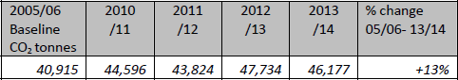
The table above shows that the Council’s emissions continue to rise. Total CO2 emissions from Falkirk Council have increased by approximately 13% over the last 8 years. This is despite a continued programme of efficiencies in terms of building energy, fleet and staff travel reduction. The quality of data relating to building energy increased greatly from 2010/11, however, the three year period since then also shows continued growth. The reasons behind the growth since 2005/06 are largely building energy related and are a combination of:

- Improved accuracy and robustness of data (some meters had not been included and this led to under%recording of energy use.)
- Replacement of secondary schools by higher energy consuming community hubs with swimming pools.
- Continued gradual extension of the Council’s built estate
- Continued gradual increase of energy use in office buildings
- Advanced age and structural condition of buildings e.g. leisure centres
- Increased computer and electronic equipment usage

The continued increase in CO2 emissions comes despite many of the planned and additional carbon reduction actions being successfully delivered. This report focuses on the period 2013/14 and actions delivered within that period alone include:
- LED lighting project at Callendar House
- Leisure centre efficiency programmes on lighting, pool insulation and pump efficiencies
- Fitting of tracking units to Council owned fleet and mechanical equipment
- Household food collection programmes, which target particularly potent greenhouse gases (Full details can be found in sections 2.6 and 2.7 of the appended report).
2.6 Proposed actions on CO2 reduction are many and varied, including:
- Approving and implementing a heating management approach
- Rationalising the property portfolio
- Optimising use of the built estate
- Use of fleet computer technology to optimise route planning and fleet use
- Drive forward and support a programme of energy efficiency projects

A considerable effort is being put into the Council’s property portfolio. The new HQ building will be more efficient than most current buildings and will allow for the disposal of less suitable stock. Other initiatives such as a new heating management approach will assist with this. There will also be a targeted investment in the remaining buildings.

Reducing Emissions From the Local Authority Area:
By signing Scotland’s Climate Change Declaration, Falkirk Council agreed to work with others in our local community to address climate change issues across the wider Council area. Estimates of carbon emissions for the Falkirk Council area (source Department for Energy and Climate Change), show that compared with other Scottish local authority areas, Falkirk Council’s has one of the highest tonnages of CO2 per person. This reflects the concentration of industry at Grangemouth. This is countered by the contribution of many of the Council’s policies and activities such as:
- Falkirk Local Development Plan % requirements for low and zero carbon buildings support of renewable energy technology where appropriate.
- Local Housing Strategy – substantial funds were secured in 2013/14 for home energy initiatives, helping to reduce household fuel bills, cut carbon emissions and create jobs.
- National Heat Networking Project – collated data relating to Falkirk Council estate to inform future projects aligning excess heat supply and demand for both business and domestic use.

Adapting to a Changing Climate:
As a public body, Falkirk Council has a duty to contribute to national programmes to help Scotland to adapt to the impacts of a changing climate. In the period 2013/14, the potential impact of severe weather events was incorporated into the Corporate Risk Register. Work also started on a Council%wide, risk based strategy to address this. The Emergency Planning Unit continued to support two Community Councils as they developed their own Community Emergency Plans. Civil contingencies and emergency preparedness procedures continued to be constantly revised and updated.

Working in Partnership:
In 2013/14, Falkirk Council continued to work in a wide variety of partnerships that contributed to climate change and sustainability efforts. This includes sharing resource efficiency best practice through the Community Planning Sustainability Group, protection of wildlife and landscape through biodiversity related partnerships as well as partnership working with housing associations to address fuel efficiency in homes. Contingency planning and emergency preparedness planning ensured that community planning partners and local businesses were engaged and had access to support.”

Conclusions and Proposed Actions

Conclusions from New Monitoring Data
Falkirk Council has examined its automatic and non%automatic monitoring results. It is concluded that:
% No new Detailed Assessments of any pollutant is required. Automatic monitoring has commenced along Main St in Bainsford to support the outstanding Detailed Assessment in the area.
% The number of exceedances in the Grangemouth AQMA has reduced compared to before the commissioning of the Tail Gas Unit. However, in 2014 the number of exceedances of the 15%minute objective concentration recorded at the Grangemouth MC (A10) site could be considered to be close to the objective. The Grangemouth AQMA remains justified based upon the 2014 Grangemouth MC results. However, the strength of this justification has significantly weakened compared to when breaches of the objective were being recorded (between 2007 and 2012).
% The Falkirk Town Centre AQMA remains justified with a breach of the NO₂ objective along Falkirk West Bridge St. Although PM₁₀ concentrations appear to be reducing at the Falkirk West Bridge St (A7) site.
% The Haggs AQMA remains under review and the monitoring has again met the NO₂ objectives and the PM₁₀ objectives in 2014.
% The roadside and background monitoring in the Banknock AQMA is operating in the area. Any decision on the status of the AQMA will be made once the new Tomfyne quarry begins operation.

Conclusions from Assessment of Sources
Falkirk Council has conducted a review of potential sources of the seven pollutants. Emissions from other transport sources, industrial and other sources did not require further consideration. The review found no requirement for any new Detailed Assessments of any pollutant.

Proposed Actions
The 2015 U&SA report has found no requirement to conduct a Detailed Assessment of any pollutant at any location in the Falkirk Council area.

Falkirk Council will continue to assess and monitor SO₂ concentrations in the Grangemouth AQMA and NO₂ and PM₁₀ in the Haggs AQMA. To ensure that SO₂ monitoring can continue the replacement of two analysers, likely to be at Bo’ness and Grangemouth Moray, shall be investigated.

The automatic monitoring NO_{x} and PM₁₀ on Main St Bainsford commenced in June 2015 in relation to the Detailed Assessment along this street. The automatic and non%automatic results will be considered after one%year of monitoring as part of the Detailed Assessment.

A 2016 air quality report as required by the Scottish Government shall be submitted.

References
General:
Technical Guidance LAQM.TG(09), Defra and Devolved Administrations, February 2009 and subsequent web updates. http://www.defra.gov.uk/environment/quality/air/air%quality/laqm/

Specific:
- a. Openair via Scottish Air Quality Network, http://www.scottishairquality.co.uk/openair/openair.php
b. D.Carslaw and K.Ropkins, Openair: Open%source tools for the analysis of air pollution data. R package version 2.14.1 and Openair 0.5%18.
- Personal communication, INEOS Community Air Monitoring Report Ambient Atmospheric Survey in the Vicinity of Grangemouth % 2014.
- Department for Transport, Falkirk Council area Traffic Counts. http://www.dft.gov.uk/traffic%counts/area.php?region=Scotland&la=Falkirk
- Falkirk Football Club, First Bus Launch, http://www.falkirkfc.co.uk/housty%parks% the%bus%with%first%bluebird/
- Bus and Coach website: http://www.busandcoach.com/news/articles/euro%6%and% virtual%electrics%feature%in%first%s%777million%order/
- Civil Aviation Authority, UK Airport Statistics http://www.caa.co.uk/default.aspx?catid=80&pagetype=88&pageid=3&sglid=3#D ata
- Scottish Railway Preservation Society, timetable for Bo’ness and Kinneil Railway, http://www.srps.org.uk/railway/timetable.htm
- Personal communication, Forth Ports.
- Scottish Air Quality Network: http://www.scottishairquality.co.uk/verification_and_ratification.php

All websites were accessible in June 2015.

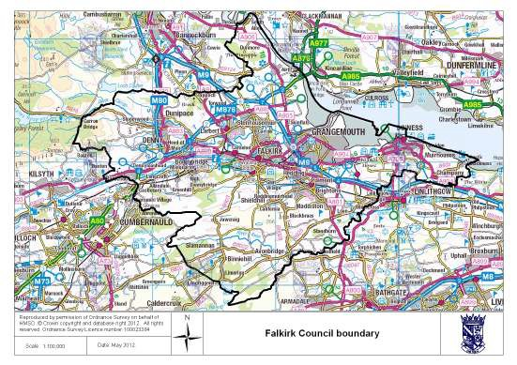
Appendices
Appendix A: Falkirk Council boundary and QA/QC of monitoring data. Appendix B: DMRB Calculations.

Appendix A: Falkirk Council boundary and QA/QC of monitoring data Figure A1 The boundary of the Falkirk Council area.

Factors from Local Co-location Studies
In 2014 the nitrogen dioxide, benzene and 1,3 butadiene tubes used by Falkirk Council were supplied and analysed by Environmental Scientifics Group in Didcot (formerly called Harwell Scientifics). The method used for the NO₂ tubes is 50% acetone and 50% tri%ethanolamine. The tubes used for benzene are Chromosorb ATD (atomic thermal desorption) tubes and for 1,3 butadiene are molecular sieve ATD tubes.

In 2014 Falkirk Council carried out three triplicate studies. This involves three NO₂ diffusion tubes being co%located with an automatic monitoring station. This enables the diffusion tube results to be bias adjusted. This is conducted to account for the difference between results from an automatic monitor and the diffusion tubes. The first study was located at the Grangemouth MC site (NA42 / A10), an urban background site. The second study at the Falkirk Park St site (NA70 / A6), a roadside site and finally a third study at Falkirk West Bridge St (NA111 / A7). However, the Falkirk Park St monitoring site, and therefore the

triplicate study, ceased in April 2014. The replacement roadside study commenced at Falkirk West Bridge St in July 2014.

The results from the three sites were submitted to the R&A bias factor for ESG Didcot, however, Falkirk Park St and West Bridge St did not contribute to this factor because of the short monitoring periods. The bias sheet from Grangemouth MC and the R&A helpdesk summary are shown in Figures A2 and A3.

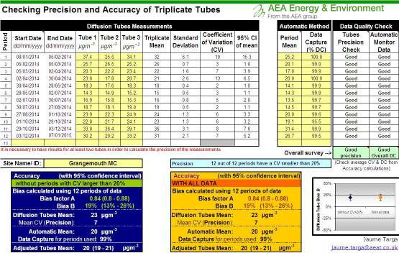
The local and R&A Helpdesk bias adjustment factors suggest that the diffusion tubes over% read NO₂ compared to the automatic monitors. Falkirk Council has applied the R&A helpdesk factor to the 2014 results because there are a mixture of roadside and background sites and no valid local roadside bias factor was available in 2014. The R&A bias factor for the ESG Didcot tubes in 2014 was 0.81. Note the data submitted to the R&A Helpdesk was provisional between July and December as the data is compiled prior to ratification. The
ratification of the automatic monitoring data does not usually change the bias factor significantly.

Discussion of Choice of Factor to Use
The local and R&A Helpdesk bias adjustment factors suggest that the diffusion tubes over% read NO₂ compared to the automatic monitors. Falkirk Council has used the R&A helpdesk factor to adjust the 2014 results. This is because there was only a local background site
available in 2014 with neither of the roadside studies in operation for more than nine months.
Figure A2
sheet.
NO₂ bias adjustment factor at Grangemouth MC (A10) and the R&A bias

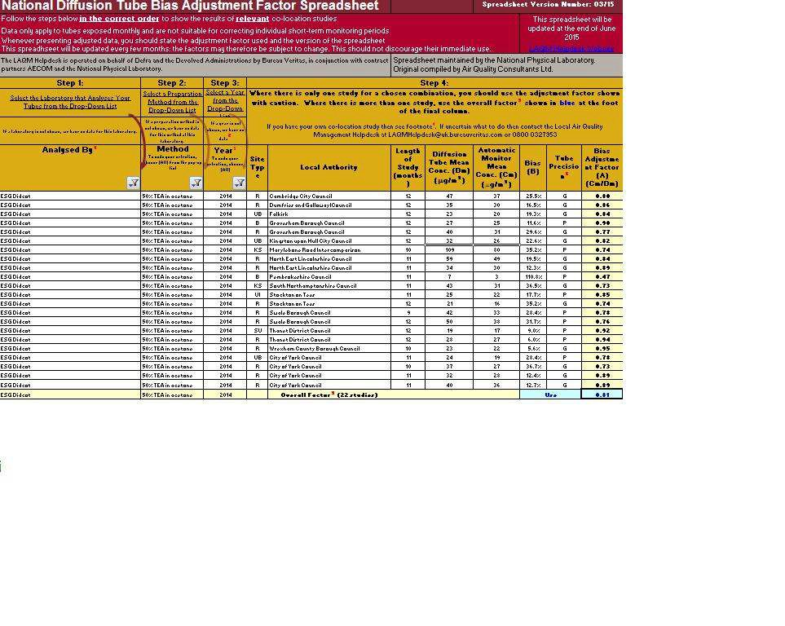
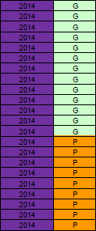

Figure A3: Precision of ESG Didcot, 50% TEA/Acetone diffusion tubes in 2014.

PM₁₀ Monitoring Adjustment
All TEOM data from 2008 onwards has been adjusted using the King’s College London Volatile Correction Method (VCM). This was carried out by Ricardo%AEA for the sites affiliated to the Scottish Air Quality Network in 2014 as part of the Scottish Government’s contract.

The PM₁₀ monitor at the Grangemouth AURN site has been a FDMS since April 2009 and so no correction factor has been applied to this data. The VCM has been applied to the 2008 and 2009 TEOM data by King’s College under contract to Defra.

The Banknock 3 Osiris data has been adjusted by a factor of 1.14. The Osiris output is a 15% minute average, these have been converted to an hourly and daily average using Enview software.

Short-term to Long-term Data Adjustment
Short%term to long%term adjustment has not been conducted for the Banknock 3 monitoring results given the potential for local sources to be impacting the monitoring results.

Monitoring results have been adjusted for the appropriate diffusion tubes and automatic analysers where data capture was substantially below 90%, details are shown in Table A1.

Table A1 Short-term to long-term adjustments.

A6: Falkirk Park St | Site Type | Annual Mean (2014),  Bg/m³ | Data capture 2014, % | Period Mean, Bg/m³ | Ratio
Grangemouth  AURN | Urban  background. | 16.3 | 95.3 | 17.1 | 0.95
Grangemouth  Moray | Urban  background. | 15.4 | 92 | 16.0 | 0.96
 |  |  |  | Average | 0.96

NA70: Falkirk Park St | Site Type | Annual Mean (2014),  Bg/m³ | Data capture 2014, % | Period Mean, Bg/m³ | Ratio
Grangemouth  AURN | Urban  background. | 16.3 | 95.3 | 17.2 | 0.95
Grangemouth  Moray | Urban  background. | 15.4 | 92 | 16.2 | 0.95
 |  |  |  | Average | 0.95

NA110: Banknock 2 AQ Station | Site Type | Annual Mean (2014),  Bg/m³ | Data capture 2014, % | Period Mean, Bg/m³ | Ratio
Grangemouth  AURN | Urban background. | 16.3 | 95.3 | 16.0 | 1.02
Grangemouth  Moray | Urban background. | 15.4 | 92 | 15.0 | 1.03
 |  |  |  | Average | 1.02

NA111: Falkirk West Bridge St | Site Type | Annual Mean (2014),  Bg/m³ | Data capture 2014, % | Period Mean, Bg/m³ | Ratio
Grangemouth  AURN | Urban  background. | 16.3 | 95.3 | 16.5 | 0.99
Grangemouth  Moray | Urban  background. | 15.4 | 92 | 15.8 | 0.97
 |  |  |  | Average | 0.98

NA112: Philip St Bainsford | Site Type | Annual Mean (2014),  Bg/m³ | Data capture 2014, % | Period Mean, Bg/m³ | Ratio
Grangemouth AURN | Urban background. | 16.3 | 95.3 | 22.6 | 0.72
Grangemouth Moray | Urban background. | 15.4 | 92 | 22.0 | 0.70
 |  |  |  | Average | 0.71

QA/QC Automatic Monitoring
Table A2 Details of the QA/QC at the automatic monitoring stations in 2014.

QA / QC in 2014.
Site | Analyser | Network
A3. Bo'ness | SO₂ | Local *
A4. Falkirk Haggs | NO_{x} | SAQN
A4. Falkirk Haggs | PM10 (TEOM) | SAQN
A5. Falkirk Hope St | NO_{x} | SAQN
A5. Falkirk Hope St | SO₂ | SAQN
A6. Falkirk Park St | NO_{x} | SAQN
A6. Falkirk Park St | PM₁₀ (TEOM) | SAQN
A6. Falkirk Park St | SO₂ | SAQN
A7. Falkirk West Bridge St | NO_{x} | SAQN
A7. Falkirk West Bridge St | PM₁₀ (TEOM) | SAQN
A8. Grangemouth AURN (Inchyra) | NO_{x} | AURN
A8. Grangemouth AURN (Inchyra) | PM₁₀ (TEOM%  FDMS) | AURN
A8. Grangemouth AURN (Inchyra) | PM_{2.5} (TEOM%  FDMS) | AURN
A8. Grangemouth AURN (Inchyra) | SO₂ | AURN
A9. Grangemouth Moray | NO_{x} | AURN
A9. Grangemouth Moray | SO₂ | SAQN
A10. Grangemouth Municipal Chambers | NO_{x} | SAQN
A10. Grangemouth Municipal Chambers | PM₁₀ (TEOM) | SAQN
A10. Grangemouth Municipal Chambers | SO₂ | SAQN
A12. Falkirk Grahams  Rd | PM₁₀ (TEOM) | Local *
A13. Banknock 2 | PM₁₀ (TEOM) | SAQN
A14. Banknock 3 | PM₁₀ (Osiris) | Local #

Local sites (*):

% | Suspicious data or data recorded when a fault is occurring is automatically marked
invalid by software. Data is also manually checked and marked invalid if it is
suspicious.
% | All NO_{x} | and SO₂ | analysers receive fortnightly zero and span checks and filter
changes.
% | All LSO site visits are carried out by Falkirk Council staff who are audited to AURN
standards.
% | Analysers are covered by a contract for emergency callout and receive a service
every six months.
% | Zero and span scaling is carried out on the data in%house based on the fortnightly site
 | visits and additionally for the Horiba sites the auto%calibrations occurring every three
 | days. Span adjustments are based on the concentration that is stated on the gas

cylinders. No independent check is made of the cylinder concentrations, though cylinders are replaced if contamination is suspected.

Local sites (#):

% | Data is downloaded at site and a flow check is carried out on a fortnightly basis.
% | A filter change is carried out on an approximate four weekly basis, although this is
 | dependent on the weather and filter loading. The filters are retained for analysis.
% | Some minor adjustment of the times for the data has taken place. This is because
 | between a flow check or filter change and the next midnight hour, the Osiris records
 | data in 15%minute blocks at say 12, 27, 42, 57 mins past the hour rather than the
 | usual 15, 30, 45 and 00. This should have little effect on the results and permits the
 | data to fit into the Council’s monitoring database which it otherwise would not.
% | As with the other sites all LSO site visits are carried out by Falkirk Council staff who
 | are audited to AURN standards.
% | The Osiris is serviced on an annual basis and covered by a service agreement for any
 | breakdowns, both are completed off%site.
% | A 1.14 correction factor has been applied to the Banknock 3 (Osiris) PM₁₀ data.

AURN and Scottish AQ network sites:
% All NO_{x} and SO₂ analysers receive fortnightly zero and span checks and filter changes.
% TEOM heads are cleaned and the filter changed on a four weekly basis or more frequently if the filter loading goes above 90%.
% TEOM%FDMS heads are cleaned and filters changed as directed by AURN CMCU (i.e. at 90% loading).
% All LSO site visits are carried out by Falkirk Council staff that are audited to AURN standard.
% Analysers are covered by a contract for emergency callout and receive a service every six months.
% QA/QC is to AURN / ‘national’ standards ^{Ref} ⁹.
% Falkirk Council also checks the data on its systems and is in communication with Ricardo%AEA to ensure the best data quality. Unscaled data is supplied by Falkirk Council to Ricardo%AEA for the Scottish AQ Network sites on a six monthly basis to improve data capture.

The UKAS certificates of the analysers within the Scottish Air Quality Network (but excluding AURN) are shown in Figure A4.

Figure A4 Certificate of calibration of the Scottish Air Quality Network monitoring sites
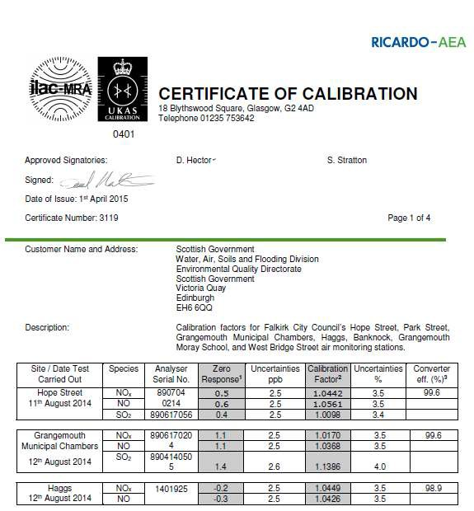
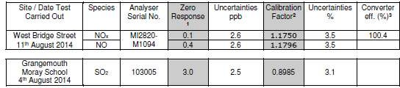

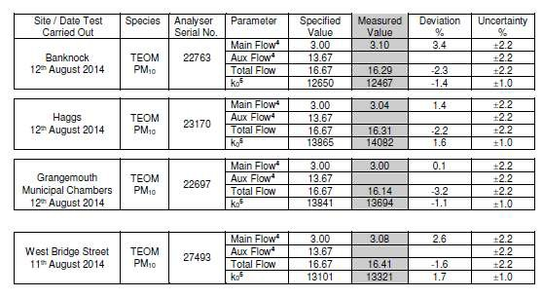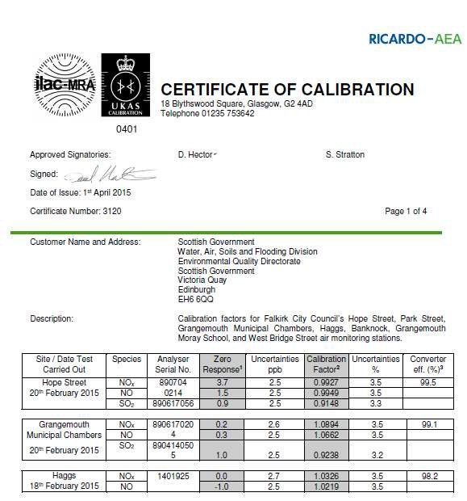

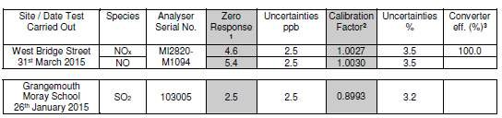
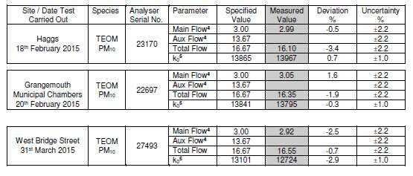
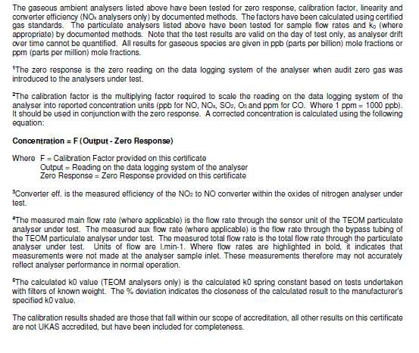

QA/QC Diffusion Tube Monitoring
ESG (formerly Harwell Scientifics) have satisfactorily passed all the WASP (Workplace Analysis Scheme for Proficiency) scheme tests since 2009. They follow their internal standard operating procedure that meets the guidelines set out in Defra’s ‘Diffusion Tubes For Ambient NO₂ Monitoring: Practical Guidance.’ ESG recorded ‘good’ precision throughout the first half of 2014 but poor in the second half.

The full pumped benzene diffusion tube results are shown in Table A3. The full set of monthly diffusion tube results are shown in Table A4.
Tube results are checked on a monthly basis and reviewed at the end of the year. Results under 4 Gg/m³ are generally not included. If a tube is found on the ground or with a spider in etc an assessment is made at the end of the year as to whether the result seems appropriate for that site and the time of year.

Table A3 Pumped diffusion tube (Grangemouth AURN) results in full.

Grangemouth AURN
Start Date | End Date | Benzene | Units | Status
23/12/2013 | 14/01/2014 | 0.78 | Gg/m³ | Verified
14/01/2014 | 21/01/2014 | 2 | Gg/m³ | Verified
21/01/2014 | 03/02/2014 | 1.75 | Gg/m³ | Verified
03/02/2014 | 17/02/2014 | 1.63 | Gg/m³ | Verified
17/02/2014 | 04/03/2014 | 1.18 | Gg/m³ | Verified
04/03/2014 | 18/03/2014 | 0.8 | Gg/m³ | Verified
18/03/2014 | 01/04/2014 | 1.28 | Gg/m³ | Verified
01/04/2014 | 15/04/2014 | 1.38 | Gg/m³ | Verified
15/04/2014 | 29/04/2014 | 0.6 | Gg/m³ | Verified
29/04/2014 | 13/05/2014 | 0.36 | Gg/m³ | Verified
13/05/2014 | 27/05/2014 | 0.91 | Gg/m³ | Verified
27/05/2014 | 10/06/2014 | 1.48 | Gg/m³ | Verified
10/06/2014 | 24/06/2014 | 0.55 | Gg/m³ | Verified
24/06/2014 | 08/07/2014 | 0.8 | Gg/m³ | Verified
08/07/2014 | 23/07/2014 | 0.82 | Gg/m³ | Verified
23/07/2014 | 05/08/2014 | 0.83 | Gg/m³ | Verified
05/08/2014 | 19/08/2014 | 0.7 | Gg/m³ | Verified
19/08/2014 | 02/09/2014 | 0.5 | Gg/m³ | Verified
02/09/2014 | 16/09/2014 | 1.21 | Gg/m³ | Verified
16/09/2014 | 30/09/2014 | 0.55 | Gg/m³ | Verified
30/09/2014 | 14/10/2014 | 0.77 | Gg/m³ | Preliminary  Verified
14/10/2014 | 28/10/2014 | 0.54 | Gg/m³ | Preliminary  Verified
28/10/2014 | 11/11/2014 | 0.97 | Gg/m³ | Preliminary  Verified
11/11/2014 | 25/11/2014 | 1.53 | Gg/m³ | Preliminary  Verified
25/11/2014 | 10/12/2014 | 1.42 | Gg/m³ | Preliminary  Verified
10/12/2014 | 23/12/2014 | 0.42 | Gg/m³ | Preliminary  Verified
23/12/2014 | 06/01/2015 | 0.98 | Gg/m³ | Preliminary  Verified

Table A4 a.) Benzene, b.) 1,3 butadiene and c.) nitrogen dioxide results in full.

a.)

Benzene | results 2014
 |  |  | Grid Reference |  | January | February | March | April | May | June | July | August | September | October | November | December | Annual average |  | Annual data  capture,
Site  number |  | Location | x | y | ppb | ppb | ppb | ppb | ppb | ppb | ppb | ppb | ppb | ppb | ppb | ppb | ppb | ug/m³ | Annual data  capture,
3 |  | Tinto Drive,Grangemouth | 293427 | 680386 | 0.88 | 0.36 | 0.41 | 0.58 | 0.37 | 0.15 | 0.17 | 0.22 | 0.34 | 0.31 | 0.5 | 0.5 | 0.40 | 1.30 | 100.0
21 |  | Grangemouth Road, College | 290112 | 680500 | 0.35 | 0.32 | 0.35 | 0.36 | 0.3 | % | 0.17 | % | 0.38 | 0.39 | % | 0.5 | 0.35 | 1.13 | 75.0
27 |  | West Bridge Street, Falkirk | 288470 | 680040 | % | 0.47 | 0.52 | 3.7 | 0.45 | 0.16 | 0.25 | 0.28 | 0.29 | 0.63 | % | 0.6 | 0.74 | 2.39 | 83.3
37 |  | Denny Town House | 281227 | 682725 | 0.32 | % | 0.26 | 0.81 | 0.27 | 0.15 | 0.23 | 0.17 | 0.26 | 0.33 | 0.6 | 0.3 | 0.34 | 1.09 | 91.7
38 |  | Larbert Village Primary School | 285930 | 682318 | 0.37 | 0.27 | 0.54 | 0.41 | 0.25 | 0.15 | 0.17 | 0.17 | 0.26 | 0.34 | 0.5 | 0.4 | 0.32 | 1.04 | 100.0
41 |  | Seaview Place, Bo'ness | 299720 | 681600 | 0.6 | 1.2 | 0.47 | 0.63 | 0.58 | 0.15 | % | % | 0.39 | 0.44 | 1 | 0.6 | 0.61 | 1.97 | 83.3
42 |  | Municipal Chambers, Grangemouth | 292800 | 682000 | 0.4 | % | 0.32 | - | 0.32 | % | 0.18 | 0.19 | 0.32 | 0.42 | 0.8 | 0.5 | 0.38 | 1.25 | 75.0
44 |  | Greenpark Drive, Polmont | 293550 | 678860 | 0.33 | 0.27 | 0.31 | 1.3 | 0.26 | 0.15 | 0.17 | % | % | 0.32 | 0.6 | 0.4 | 0.41 | 1.34 | 83.3
55 |  | Inchyra Station | 293833 | 681014 | 0.42 | 0.38 | 0.51 | 0.56 | % | 0.2 | 0.21 | % | 0.57 | 0.31 | 0.5 | 0.4 | 0.41 | 1.32 | 83.3
57 |  | Inchyra Road, Grangemouth | 294028 | 680829 | 0.7 | 0.46 | 0.8 | 0.84 | 1.2 | 0.26 | % | 0.27 | % | 0.39 | 0.7 | 0.4 | 0.60 | 1.96 | 83.3
77 |  | Kinnaird Village | 286490 | 683775 | 0.54 | 0.27 | 0.27 | 0.42 | 0.32 | 0.15 | % | 0.17 | 0.44 | 0.25 | 0.3 | 0.4 | 0.32 | 1.04 | 91.7
80 |  | Cow Wynd | 288765 | 679456 | 0.42 | 0.41 | 0.38 | 0.55 | 0.34 | % | 0.21 | 0.17 | 0.5 | 0.42 | 0.6 | 0.5 | 0.41 | 1.33 | 91.7
81 |  | Grahams Road, Falkirk | 288834 | 680898 | 0.54 | 0.46 | 0.38 | 0.49 | 0.43 | 0.19 | 0.17 | 0.17 | 0.51 | 0.29 | 0.6 | 0.4 | 0.39 | 1.25 | 100.0
94 |  | A905 (Glensburgh Rd),  Grangemouth | 291213 | 681927 | 0.4 | 0.33 | 0.33 | 0.49 | 0.44 | 0.15 | 0.24 | 0.17 | 0.32 | 0.3 | 0.6 | 0.4 | 0.35 | 1.13 | 100.0
102 |  | East Kerse Mains, Bo'ness | 297968 | 680684 | 0.28 | 0.31 | 0.32 | 0.47 | 0.28 | 0.15 | 0.17 | 1.1 | 0.26 | 0.24 | 0.7 | % | 0.39 | 1.26 | 91.7
105 |  | West of Shieldhill | 288284 | 676881 | 0.23 | 0.21 | 0.25 | 0.33 | 0.18 | 0.15 | 0.17 | % | 0.35 | 0.24 | 0.2 | 0.2 | 0.23 | 0.74 | 91.7

b.)
1,3 butadiene results 2014

 |  | Grid Ref |  | January | February | March | April | May | June | July | August | September | October | November | December | Annual Average |  | Annual  data
Site No | Address | x | y | ppb | ppb | ppb | ppb | ppb | ppb | ppb | ppb | ppb | ppb | ppb | ppb | ppb | Bg/m⁻³ | Annual  data
41 | Seaview Place, Bo'ness | 299720 | 681600 | 0.6 | 0.6 | 0.6 | 0.08 | 0.07 | 0.07 | 0.05 | 0.07 | 0.06 | 0.02 | 0.02 | 0.02 | 0.19 | 0.42 | 100.0
55 | Inchyra Station, Grangemouth | 293833 | 681014 | 0.6 | 0.6 | 0.6 | % | 0.13 | 0.13 | 0.06 | 0.03 | 0.07 | 0.02 | 0.07 | 0.03 | 0.21 | 0.48 | 91.7
104 | Powdrake Road, Grangemouth | 293788 | 682054 | 0.6 | 0.6 | 0.6 | 0.12 | 0.02 | 0.02 | 0.08 | % | 0.06 | 0.05 | 0.13 | 0.02 | 0.21 | 0.47 | 91.7

Site No | Address | Grid ref, x | Grid ref, y | Jan | Feb | Mar | April | May | June | July | Aug | Sept | Oct | Nov | Dec
3 | Tinto Drive, Grangemouth | 293427 | 680386 | 30.1 | 28.8 | 24.6 | 18.6 | 14.5 | 15.7 | 24.3 | 18.7 | 21.1 | 26.1 | 30.6 | 30.9
5 | Copper Top Pub, Camelon | 287332 | 680333 | 41.6 | 35.9 | 34 | 45.2 | 25.3 | 15.7 | 24.8 | 28.2 | 32.2 | 34.6 | 53 | 32.4
7 | Irving Parish Church, Camelon | 287324 | 680442 | 37.8 | 21.8 | 21.7 | 19.9 | 15.6 | 13.5 | 13.6 | 15.1 | 22.6 | 18 | 33.1 | 28.9
9 | Bellsdyke Road, Larbert | 286048 | 683542 | 39 | 42.2 | 41 | 28 | 26.5 | 22 | 28.3 | 35 | 37.8 | 37.2 | 51.7 | 44.1
19 | Kilsyth Road, Banknock | 278779 | 679301 | 49.3 | 43.5 | 45 | % | 42.2 | 39.3 | % | % | 41.9 | 39.1 | 53.1 | %
20 | Garngrew Road, Haggs | 278957 | 679169 | 41.2 | % | 25.6 | 25.2 | 24 | % | 21.6 | 23.9 | 28.8 | 29.8 | % | 26.8
21 | Grangemouth Road, College | 290112 | 680500 | 40.6 | 35.6 | 34.9 | 33.7 | 28 | % | 23.6 | 27.1 | 38.3 | 35.1 | 42.6 | 40.3
24 | Kerse Lane, Falkirk | 289189 | 680018 | 47.8 | 53.4 | 49.1 | 47.4 | 43.1 | 39.9 | 15.7 | 50.4 | 56.2 | 40.2 | 57.9 | 50.7
26 | Weir Street, Falkirk | 289207 | 680123 | 36.6 | 27 | 15.9 | 22.7 | 18.3 | 11.9 | 16.2 | 17.2 | 19.8 | 23.8 | 33.2 | 26.2
27 | West Bridge Street, Falkirk | 288490 | 680055 | 73.6 | 58 | 57.6 | 62.8 | 54.7 | 48 | 29.7 | 56 | 68.1 | 43.2 | 66.8 | 41.8
29 | Wellside Place, Falkirk | 288465 | 680220 | 27.1 | 23.1 | 23.6 | 23.1 | 14.9 | 15.4 | 17.3 | 16 | 23.8 | 15.9 | 36.5 | 21.8
36 | Kerr Crescent, Haggs | 278985 | 679273 | 49.6 | 50.8 | 49.7 | 53.8 | 40 | 36.5 | 43.1 | 44.2 | 48 | 40.1 | 58.2 | 54.9
37 | Denny Town House | 281226 | 682526 | 42.5 | 23.9 | 23.8 | 21.7 | 17.4 | 15.1 | 15.6 | 17.2 | 23.8 | 20.8 | 40.2 | 28.2
38 | Larbert Village Primary School | 285930 | 682318 | 34.2 | 22.6 | 21.1 | 20.8 | 14.4 | 13.3 | 13.2 | 16.1 | 22.6 | 22.1 | 33.6 | 26.7
41 | Seaview Place, Bo'ness | 299722 | 681594 | 37.4 | 27.1 | 26.4 | 22.6 | 20.3 | 19.1 | 18.6 | 19.2 | 25.5 | 24.3 | 38.8 | 29.7
42 | Municipal Chambers, Grangemouth | 292817 | 682000 | 37.4 | 25.7 | 20.3 | 23 | 18.3 | 14.3 | 16.9 | 18.7 | 23.9 | 22 | 33 | 30.2
42 | Municipal Chambers, Grangemouth | 292817 | 682000 | 25.5 | 26.5 | 22.2 | 17.8 | 17.6 | 14.9 | 15.8 | 18.1 | 22.3 | 21.7 | 36.4 | 29.2
42 | Municipal Chambers, Grangemouth | 292817 | 682000 | 34.1 | 25.2 | 23.4 | 20.7 | 18.3 | 15.2 | 15.3 | 19 | 24.9 | 24.1 | 39.1 | 33.2
44 | Greenpark Drive, Polmont | 293436 | 678938 | 32.3 | 20.8 | 19.3 | 18.3 | 12.3 | 10.3 | 8.7 | % | 19.7 | 19.2 | 28.5 | 24.5
48 | Hayfield, Falkirk | 289200 | 681580 | 37.4 | 26.7 | 26.4 | 25.7 | 16.4 | 16.8 | 17.5 | 16.7 | 22.2 | 24.2 | 41.1 | 24.6
50 | Upper Newmarket Street | 288671 | 680047 | 31.8 | 31.2 | 31 | 41 | 27.7 | 32.2 | 26.5 | 31.2 | 39.7 | 30.4 | 42.2 | 28.3
51 | Mary Street, Laurieston | 290965 | 679490 | 35.7 | 32.4 | 28 | 28.8 | 29.6 | 25 | 27.6 | 27.9 | 33 | 27.5 | 39.3 | 30
52 | Main Street, Larbert | 285866 | 682356 | 44.7 | 27.8 | 25.5 | 23.3 | 20.9 | 17.1 | 19 | 20.1 | 25.3 | 26.1 | 37.6 | 29.7
53 | Denny Cross | 281211 | 682727 | 59.1 | 34 | 40.4 | 42 | 34.9 | 29.7 | 29.6 | 29.2 | 34.5 | 35.4 | 57.7 | 33.6
57 | Inchyra Road, Grangemouth | 294028 | 680829 | 37.5 | 35.6 | 32.2 | 25.7 | 22.4 | 18.6 | 50.6 | 21.6 | 30.3 | 33 | 45.1 | 31.6
58 | Callendar Road, Falkirk | 289667 | 679724 | 42.4 | 25.7 | 25.8 | 25.1 | 20.9 | 17.7 | 15.6 | 19 | 24 | 25.6 | 38.9 | 27.4
59 | Carron Road, Bainsford | 288392 | 681931 | 39.6 | 36.9 | 32.1 | 30.9 | 22.4 | 23.4 | 22.3 | 28.6 | 35.3 | 27.1 | 50 | 41.2
60 | Ronades Road, Carron | 288133 | 681587 | 40.6 | 39 | 34.3 | 31.4 | 25.8 | 19.8 | 24.4 | 24.8 | 34.7 | 37.5 | 53.2 | 28.4
61 | Canal Rd, Falkirk | 287976 | 680656 | 44.7 | 35.9 | 30.6 | 31.1 | 24 | 24 | 21.1 | 25.7 | 32.3 | 32.1 | 39.2 | %
62 | Arnot Street, Falkirk | 289125 | 679705 | 56.7 | 53.6 | 50.9 | 42.2 | 40.9 | 36.3 | 37.7 | 36.4 | 48 | 46 | 63.8 | 46
63 | Camelon Road, Falkirk | 288055 | 680134 | 58.7 | 50.4 | 47.4 | 43.7 | 38.3 | 26.6 | 33.4 | 38.8 | 46.5 | 43.1 | 59.3 | 54.1
64 | New Hallglen Road, Hallglen | 288807 | 678422 | 36.7 | 22 | 25.6 | 18.8 | 21.1 | 13.9 | 16.4 | 19 | 25.5 | 21.5 | 32.6 | 19.6
65 | Redding Road, Redding | 291356 | 678644 | 34.9 | 22.4 | 20.5 | 14.3 | 13.4 | 13.8 | 11.3 | 14.3 | 21.5 | % | 43 | 35.5
67 | Queen Street, Falkirk | 289430 | 680433 | 46.5 | 36.7 | 40.3 | 34.5 | 27.3 | 22.4 | 23.9 | 29.9 | 29.5 | 30 | 49.4 | 39.2
68 | Belluvue Street Falkirk | 289234 | 679945 | 49.3 | 43.1 | 41.5 | 17.9 | 23.5 | 25.4 | 22 | 35.8 | 39.6 | 37.7 | 49.2 | 46.8
69 | Kerse Lane, Falkirk | 289025 | 679991 | 54.7 | 40.2 | 44.1 | 36.4 | 36.9 | 29.9 | 42.8 | 39.2 | 47.3 | 41.9 | 58.7 | 39.6
70 | Park Street AQ station, Falkirk | 288892 | 680070 | 44.3 | 36.5 | 36.7 | 32.3 | % | % | % | % | % | % | % | %
70 | Park Street AQ station, Falkirk | 288892 | 680070 | 46.2 | 35.3 | 37.4 | 34.1 | % | % | % | % | % | % | % | %
70 | Park Street AQ station, Falkirk | 288892 | 680070 | 43.9 | 33.8 | 33.9 | 33 | % | % | % | % | % | % | % | %
71 | Park Street, Falkirk | 288910 | 680112 | 44.6 | 47.1 | 43.3 | 39.8 | 27.7 | 36.7 | 32.8 | % | 38.4 | 39.4 | 55.6 | 38
72 | Vicar Street, Falkirk | 288824 | 680120 | 53.4 | 40.6 | 39.7 | 56.2 | 33.3 | 25.5 | 25.9 | 28.8 | 39.5 | 36.4 | 56.5 | 43.4
73 | West Bridge Street, RHS,Falkirk | 288467 | 680048 | 57.9 | 48.1 | 48.4 | 42.9 | 35.6 | 33.2 | 32 | 33.3 | 42.3 | 39.7 | % | 39
76 | Tryst Road, Stenhousemuir | 286851 | 683229 | 48.4 | 35.4 | 25.2 | 24.7 | 19.6 | 15 | 18.6 | 21.4 | 26.6 | 26.2 | 38.8 | 39.3
77 | Kinnaird Village | 286490 | 683775 | 42.4 | 32.3 | % | 26.1 | 20.6 | 14.9 | 20.4 | 22.1 | 25.6 | 27.8 | 39.5 | 31.3
78 | Glen Brae, Falkirk | 288525 | 678991 | 49.1 | 39.2 | 37.8 | 39.7 | 34.1 | 24.2 | 27.6 | 29.8 | 38.9 | 38.5 | 48.8 | 43.9
80 | Cow Wynd, Falkirk | 288765 | 679456 | 51.3 | % | % | % | 30.1 | 28.3 | 31.9 | 34.6 | 41 | 31.5 | 45.3 | 36.3
81 | Grahams Road, Falkirk | 288834 | 680898 | 54.2 | 38.1 | 33.8 | 33.8 | 28 | 27.7 | % | 24.4 | 37.8 | 30.4 | 54.3 | 34.2
82 | Castings Ave, Falkirk | 288858 | 681036 | 38.8 | 27.7 | 22.2 | 15.9 | 15 | 9 | 15.4 | 14.8 | 23.9 | 21.8 | 37 | 29.5
83 | Main Street, Bainsford | 288614 | 681415 | 52.3 | 53.3 | 38.4 | 45.2 | 30.7 | 22.1 | 34.2 | 31.7 | 46.8 | 46.7 | 56.4 | 51.1
85 | Auchincloch Drive, Banknock | 278752 | 679049 | 44.8 | 26.9 | 24.2 | 30.2 | 25.8 | 15.7 | 12.8 | 18.2 | 25 | 22.5 | 40.1 | 27.6
86 | Wolfe Rd, Falkirk | 289667 | 679871 | 28.1 | 18.1 | 21.8 | 19.3 | 14.7 | 10 | 12.6 | 12.7 | 18.5 | 18.8 | 33.3 | 21.4
87 | M80 slip south, Haggs | 279017 | 679305 | 40.4 | 47.8 | 35.6 | 37.5 | 33.2 | 30.3 | 35.5 | 35.8 | 40 | 37.7 | 51.9 | 44.3
88 | Ure Crescent, Bonnybridge | 282444 | 681074 | 45.7 | 36.6 | 31.2 | 29.3 | 28.2 | 23.9 | 26.6 | 34.7 | 37.7 | 33.5 | 47.5 | 47.4
89 | Grahams Rd/Meeks Rd, Falkirk | 288853 | 680328 | 41.6 | 40.3 | % | % | 35.7 | 29 | 31.1 | 35 | 39 | 37.1 | 45 | 30.7
94 | A905 (Glensburgh Rd), Grangemouth | 291213 | 681927 | 53.8 | 34.4 | 38.2 | 36.5 | 30.7 | 26 | 30.5 | 38.4 | 42.5 | 41.6 | 46.8 | %
98 | Arnothill, Falkirk | 288095 | 680105 | % | % | 28.1 | 30.5 | % | 23 | 22.6 | 21.9 | 27.6 | 25.6 | 36.3 | %
99 | St Crispins Place, Falkirk | 288924 | 679675 | 41.4 | 26.5 | 26.2 | 33.6 | 28 | 24 | 26.6 | 28.8 | 35.4 | 25.3 | 41.2 | 33.5
100 | Oswald St, Falkirk | 288977 | 679662 | 31.2 | 19.3 | 25.6 | 22.1 | 22.9 | 21 | 18.7 | 21.3 | 27 | % | 25.4 | 30.6
101 | Glensburgh Road, Grangemouth (2) | 291127 | 682007 | 46.2 | 30.7 | 29.2 | 25.3 | 22.3 | % | 20.9 | 22.8 | 28.4 | 27.7 | 45.8 | 29
103 | Merchiston Gardens | 288270 | 680989 | 35.6 | 22.5 | 21.1 | 18.4 | 16.1 | 9.3 | 15.7 | 16.9 | 21.9 | % | % | %
105 | West of Shieldhill | 288292 | 676889 | 17.5 | 10.1 | 11.2 | 8.2 | 7.6 | 7 | 7.5 | 7.2 | 11 | 9.2 | 18.5 | 11.6
107 | Main Street (east), Bainsford | 288640 | 681396 | 52.9 | 38.2 | 38.6 | 35.2 | 30 | 29.6 | 26.9 | 30.3 | 39 | 30.3 | 50.2 | 37.8
108 | Main Street, Camelon | 286834 | 680512 | 37.5 | 26.4 | 27.1 | 26.3 | 25.9 | 24.5 | 21.4 | 26.6 | 31.3 | 25 | 45.7 | 21.9
109 | Carmuirs Street, Camelon | 286786 | 680488 | 35.9 | 20.2 | 22.3 | 20.8 | 15.7 | % | 14 | 17.9 | 20 | 23 | 32.6 | 21.1
110 | Banknock 2 AQ station | 277247 | 679027 | % | % | % | 21.1 | 19.5 | 16.2 | 18.9 | 17.9 | 23.4 | 18.9 | 31.8 | 32.2
111 | Falkirk West Bridge St AQ station | 288457 | 680064 | % | % | % | % | % | % | 38.4 | 39.9 | 31 | 41.6 | 61.1 | 43
111 | Falkirk West Bridge St AQ station | 288457 | 680064 | % | % | % | % | % | % | 37.1 | % | 49.2 | 38.2 | 58.1 | %
111 | Falkirk West Bridge St AQ station | 288457 | 680064 | % | % | % | % | % | % | 33.9 | 36.8 | % | 31.8 | 48.8 | %
112 | Philip Street, Bainsford | 288505 | 681443 | % | % | % | % | % | % | % | % | % | % | 38.9 | 17.9

Appendix B: DMRB Calculations

Table A5 Background concentrations used in DMRB runs.

Link | 2014 background concentration, Bg/m³
Link | NO_{x} | NO₂ | PM₁₀
A803 Glenfuir road to Rosebank roundabout | 20.4 | 15.5 | 13.57
A803 Bridge St to the Bypass Road  Dennyloanhead | 23.8 | 17.2 | 13.66
B9132 Abbots Road (Newhouse Road to Bo'ness Rd) | 22.8 | 15.5 | 12.83

Table A6 Other input data to the DMRB runs.

Link | %HGV | Mean speed, kph | Distance (closest) receptor to centre link, m | AADT
A803 Glenfuir road to Rosebank roundabout | 5% | 40 | 6.3 | 22,117
A803 Bridge St to the  Bypass Road Dennyloanhead | 5% | 40 | 4.0 | 9,457
B9132 Abbots Road (Newhouse Road to Bo'ness Rd) | 5% | 40 | 8.0 | 8,996

Verification

Table A7 Verification for DMRB runs.

Verification | Background NO₂ | Monitored NO₂ | Modelled NO₂ | NO₂ difference, %
NA77 Kinnaird Village | 12.6 | 28 | 15.9 | %43.1
The DMRB modelled component of PM₁₀ was adjusted by the NO_{x} ratio from a verified site. DMRB runs took account of the NO_{x} to NO₂ conversion method (April 2009).

